1. **INTRODUCTION:**

Woodlands University College (WUC) is a small university that offers a variety of degree programs. The Computing Degree at WUC is led by Dr. Simon White, who is also the course leader.

Dr. White, as course leader, has approached our software engineering company and requested that our team look into developing a computerized course management system for the computing degree program. The current system is primarily based on clerical work.

The software that our team develops is expected to be used throughout the institution if it is successful, but we have been asked to create a pilot system specifically for the computing department.

* 1. **Project Background**

This project aims to develop computerized course management process, which currently uses a clerical system to manage the course information.As course leader, Dr. White is responsible for a team of course tutors, several administrative support staff, and the current students enrolled in the course, among other things. All of these key groups will, logically, require computerized records. The pilot system should include some, if not all, of the essential functionality illustrated in Table 1 – Provisional System Functionality, in addition to storing all relevant data on all members of the computing department.

**Table 1 – Provisional System Functionality**

|  |  |
| --- | --- |
| Area | Notes/Essential Functionality |
| Student Records | Create, Amend, Archive, Display, Assign. |
| Staff Records | Create, Amend, Archive, Display, Assign. |
| Course Records | Create Structure, Amend, Display, Delete, Archive. |
| Module Management | Create, Amend, Delete, Archive, Display, Assign. |
| Assignment Management | Create, Amend, Delete, Archive, Display, Assign, Mark/Grade |
| Attendance Records | Create, Amend, Archive, Monitor, Display, Action Poor Attendance. |
| Personal Tutor Management | Create, Amend, Assign, Display, |
| Timetable Management | Create, Amend, Delete, Archive, Display |
| Diary Management | Create, Amend, Display, Prompt, Initiate Automated Action. |
| Report Generation/  Management | Create, Display, Print |

Our software development company has been contacted by the course leader Dr White to learn more about the possibility of developing a software suite product that includes:

* To store all relevant data on all members of the computing department.
* A records management system that will enable the university to efficiently manage important staff, student, and other records.
* Responsive student information portal system.

So, to develop a software as a customer requirement we formed 6 members team named **Acheron** to complete the task and provide our best wireframe design to our customer. However, we need further information regarding the university so we scheduled an interview with several of the members of university to obtain appropriate information about the university.

* 1. **Project Aim and Objectives**

The main aim of this project was to discuss the features and requirements provided by the clients and stakeholders at Workshop and to develop the student record portal,student record application and to transform the existing clerical system into a computerized system.To achieve this requirement, the goal can be set as follows:

* The provided information is examined and comprehend, such as briefings and documentation.
* The various requirements engineering processes provide a clear understanding of the problem domain.
* Gather essential issue domain information and gain a better understanding of the needs through online meetings with clients.
* Make a list of appropriate questions for key stakeholders to ask in order to gain a better understanding of the problem and possible system solutions.
* Create a specification document that contains all of the information and knowledge gained from the requirements specification documentation.
* Conduct design workshops with relevant stakeholders and move the prototype to the next development stage.
* Through a series of consultations and confirmations, implement all of the basic and essential functionalities to meet the client's requirements.
* If necessary, test and evaluate the system with clients.
* Examine the final system before presenting it to the client.

The goal of the project is to ensure that the final version of the software has all of the features and functionalities that the client requires. Because the software is intended to be user-friendly, the following features should be included:

* Attractive and educational
* It should be easy to use and accessible to all users.
* Perfect features like (effective navigation and search box)
  1. **Project Development methodology**

Following the goals mentioned above in this report, our team will take several approaches to develop a powerful and user-friendly system for this project.We will first gain a complete understanding of the problem area by conducting numerous studies. Then, in order to get some inspiration, we'll take a closer look at other systems that are similar to the one we're working on. We'll be able to get a better idea of the expected functional characteristics as a result of this.

We'll go over the laws that govern education, software, and data as well. Then we'll try to figure out what classes and objects are in the system and build a reliable data system for them. Then, based on feedback from stakeholders, we'll design the wireframe and then the UI, with appropriate functional behavior and consistent performance. After we've completed all of those steps, we'll test our results to ensure that everything we've been told is correct and working.

Finally, we will validate all of our work in order to raise its standard. We will validate it in accordance with all applicable laws, and then we will handle our entire solution for our clients.

The project process is divided into phases, as shown in the following figure.

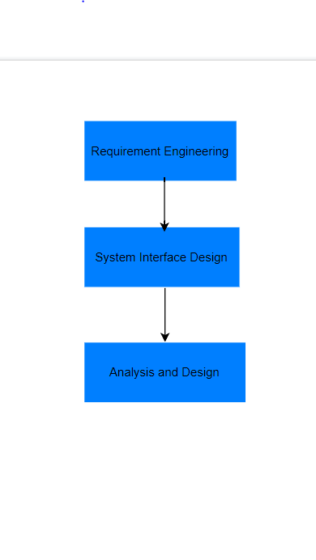

1. **Requirement Engineering:**

Requirement Engineering is the process of investigating and explaining problem areas and requirements, as well as designing and documenting the properties of the solution system that meets these criteria. Various procedures have been provided to assist us in achieving our requirement-gathering goal. Interview strategies, interview outcomes, problem domain description, similar software system review, and formulation of appropriate laws are all examples of elicitation activities. Functional requirements, performance requirements, design constraints, and commercial constraints are also described.

The goal of requirement engineering is to create and maintain a detailed and descriptive document called a "System Requirements Specification." Requirements engineering entails a number of activities in order to create the system. The following are the four steps in the Requirement Engineering process:

1. Feasibility study
2. Requirement gathering (Elicitation)
3. Software requirement specification
4. Software requirement validation

Feasibility study:

* When a client approaches an organization to have a product developed, they usually have a rough idea of what functions the software should perform and what features they expect from the software.
* With this information in mind, analysts will conduct a detailed investigation into the feasibility of the desired system and its functions.

Requirement gathering:

* If the feasibility report indicates that the project can be carried out, the next phase begins with gathering requirements from the user. Analysts and engineers communicate with clients and end-users to learn about their expectations for the software and which features they want included.

Software requirement specification:

* After gathering requirements from various stakeholders, a system analyst creates a document called a software requirement specification.
* SRS specifies how the intended software will interact with hardware, external interfaces, system speed, system response time, software portability across platforms, maintainability, and speed of recovery after a crash. Security, quality constraints, and so on.
* The client's requirements are written in a natural language style. The system analyst is responsible for documenting the requirements in technical language so that the software development team can understand and use them.
* Features for SRS:

The following features should be included in the software requirement specification:

* Natural language is used to express user requirements.
* Technical specifications are written in a structured language that is used within the company.
* Pseudo-code should be used to write the description.
* Forms and GUI screen prints in various formats.
* Conditional and numerical documentations for data stream charts etc.

Software requirement validation:

* The requirements method in this document is validated after the requirements specifications are developed. Users may request illegal or impractical solutions, or experts may misinterpret the requirements. If not addressed, this will result in a significant increase in cost. The following conditions can be used to test requirements:

1. If they can be implemented in practice.
2. If they are correct and correspond to the software's functionality and domain.
3. If there are any doubts.
4. When they are completed.
5. If they can be illustrated.
   1. **Elicitation Activity**

Elicitation Activities is concerned with gathering data. It's also known as gathering requirements or acquiring requirements. We gather information from the client about the problem and the problem domain in this stage, create a requirements document, and distribute it to the rest of the development team.

* + 1. **Interview Plans**

We conducted interviews with the following stakeholders.

1. **Dr. Simon White:** The computing course leader.
2. **Mr. Adam Blake:** An experienced course administrator from the computing course program support team.
3. **Dr. Raj Singh:** A senior lecturer, module leader and personal tutor from the computing department.
4. **Mr. Mark Williams:** An existing student enrolled on the computing course

**Dr. Simon White (Course leader)**

* + - 1. What are the major objectives and expectations for new software development?
      2. What is your experience in this field? What strategies do you have in place to help all students achieve academic success?
      3. If possible, could you provide us the course details and other documents so that we may learn more about your previous clerical record management system process?
      4. Do you think this program has a possibility to assist the student, module, and management systems? If so, what are your thoughts?
      5. Why did you choose to partner with us on software development above all those other software companies?
      6. What type of vision do you have for new programs or services in the computer degree field? What new program or service would you like to have that your competitors don't have?
      7. How do you keep track of the number of students enrolled? Do you need help enrolling and managing students?
      8. As a course leader, how do you maintain track of the attendance course tutor, administrative support personnel, and students? Would you want some help utilizing our platform to keep track of them.
      9. What features and behaviors would you want to see on a computerized system to make students and instructors more environmentally friendly and convenient?
      10. What sort of login method do you want for employees and students in this software? Do you want them to register a new account or may they operate using their existing personal account?
      11. How do you guarantee that the course content is delivered consistently and that the course team meets on a regular basis?
      12. How are you engaging with the feedback from the students and course reps?
      13. What is the timeline for the project, in particular for thefunding, purchase, implementation, testing of the system and for evaluating the project?
      14. As a whole, I'd want to ask if you have any questions on how the new system should work, and if we missed anything that we should have asked but didn't?

**Mr. Adam Blake (Administrator):**

1. How do you give your students the lecture slides?
2. How do you keep students informed about their evaluations and examinations, as well as the lecture cancellation?
3. What type of submission method would you like for students?
4. How would you want to publish the exam results of students from various modules?
5. How many distinct permission modes should the new system have, and who should have admin power to make user interaction simple and secure?
6. How frequently do you organize internship-related activities for students to assist them grow in their jobs, and how do you want it exhibited or circulated among students in the new system?
7. How do you prefer to provide and evaluate attendance sheets to teachers?
8. What role do you want the new system to play in ensuring that faculty data is shared with other departments and groups as needed?
9. How do you deal with general lecturer queries about procedures?
10. What is your approach to questions about assignment extensions?
11. How do you give lecturers and students miscellaneous mail merges?
12. What kind of program do you run to encourage students to be more interactive and flexible in their fields?
13. Do you want to link the learning platform with new software and have a mobile learning platform as well?

**Dr. Raj Singh (Module leader):**

As a senior lecture & module leader what are your responsibilities?

How does your current management system look like? What kind of changes can be made on your current management system?

What further modifications do you want to see in the system as a senior lecturer? What type of features and design do you want to see?

Do you want your module routines or module Information to be updated daily?

How many courses are there in total, and how did you previously provide the courses and assignments to the students? How would you want to handle everything in the new system?

How would you wish to provide student access? Can your student edit or remove their assignment after it has been submitted?

How do you intend on keeping track of student progress and accomplishment? How do you want this advancement to be shown, and who should have access to award this achievement to the student?

Do you want the program to assist you in notifying the students and tutor about the timetable change?

How do you maintain track of the student's evaluation and course and make it available to them? Who should have access to updated course materials for students, and how would you like this program to assist you?

Would you need any training session for the new system?

What type of communication option would you like to add in a system? (Email, Announcement Page, Discussion board)

Would you like admin powers, and what are your ideas on publishing grades and receiving comments in the management system, and who should have the ability to edit?

Is there anything more you'd want to note, and do you have all of the things you want? If not, what feature would you like to see added?

**Mr. Mark Williams (Student):**

1. What subjects are you presently pursuing and why did you select your university?
2. What aspects of your university education do you love the most?
3. How effective has your current academic training been in preparing you for a future in this field, and what academic goals do you hope to reach by the time you graduate?
4. Have you ever had a disagreement with a professor over your grades or performance evaluations? What were your justifications?
5. What are your thoughts on the clerically based management structure in place here?
6. Have you encountered any issues with the present management system?
7. Do you believe the existing management system is capable of adequately managing the course management process, and if so, why? If not, what changes to the current management system would you want to see?
8. Do you think a software-based system is a viable answer to the existing course management problem?
9. Should developing a modest and simple pilot system that gives the required degree of flexibility and resilience to allow for future expansion assist in the future administration of student, staff, and course data?
10. Is there anything about the existing clerical-based system that you enjoy and wish to see more of?
11. Do you have any previous experience with software-based industrial services?
12. What advantages do you believe the computerized course administration system will bring to the university's future?
13. In what ways do you believe the computerized management system will assist in reducing the workload on the staff and students?
14. What features of the computerized course management system do you believe will be beneficial to the academic atmosphere at the university?
    * 1. **Interview Findings**

Interview Title: Initial interview with Key Stakeholder-**Dr. Simon White**

Interview Date:

Duration: 1 hour

Person in attendance:

* Sushila Timalsina
* Riya Shrestha
* Rovika Gurung
* Rabindra Prasad Joshi
* Siddharth Yonzon Tamang
* Pawan Bhusal

|  |  |  |  |
| --- | --- | --- | --- |
| Stakeholder | Question | | Questions and Client responses |
| **Dr. Simon White (Course leader)** | Sushila 01 | | **What are the major objectives and expectations for new software development?**  Answer:  As things stand now, all work is done through a clerical-based system, which has caused a slew of problems and issues because these systems require a lot of manpower and everything is done manually, there is a lot of room for human error and performance issues. As a result, we're working on a new system to address these concerns.  This new program is expected to help me develop a quality-of-service system, a record management system, and student records (information portal and information applications). The new system should include all of the tutor, student, and other administrative personnel's records, as well as enable students use the new program efficiently. |
|  | Sushila 02 | | What is your experience in this field? What strategies do you have in place to help all students achieve academic success?  Answer:  I am in a position where I have 5 years of experience in my field and have encountered several problems and difficulties along the way. So I employed a few of strategies to overcome these problems and challenges. To solve the problem and improve the academic achievement of my pupils, I want them to be aware of new software not only to the students its also for the staffs and tutor of the organization so that they may learn new things from it. This new system is one of the most up-to-date strategies I'll use, so I hope you can meet all of my needs, such as tracking records to eliminate human mistakes, having everything in one place, and aiding me in helping all students improve their academic performance. |
|  | Sushila03 | | If possible, could you provide us the course details and other documents so that we may learn more about your previous clerical record management system process?  Answer:  We've given you with course material as well as extra papers to go through. We've also provided you with our requirement documentation so that you may better understand our requirements and devise a solution to meet them. |
|  | Sushila04 | | Do you think this program has a possibility to assist the student, module, and management systems? If so, what are your thoughts?  Answer:  Because it is an automated system with functionality that integrates student records, staff records, course records, module management, assignment management, timetable management, and diary management system without any human errors, I believe that this system will benefit all stakeholders, including students, module leaders, and administrators. If we integrate all of these features, we will have a reliable and acceptable system that will assist us in making our job easier and more efficient. |
|  | Sushila05 | | Why did you choose to partner with us on software development above all those other software companies?  Answer:  So we chose you based on your previous work, which was identical to ours, and we found that your work reviewing and feedback on your company's software was also superior to that of other firms. That is why we picked your organization for this project since we feel you can grasp our project requirements and satisfy our needs. |
|  | Sushila06 | | What type of vision do you have for new programs or services in the computer degree field? What new program or service would you like to have that your competitors don't have?  Answer:  In terms of the goal, this new system will assist us in adding 10 departments to it, as well as providing additional course options and upgrading our learning management system from a paper-based system to the most recent version of computerized system. Students will have a better learning experience and education quality thanks to an online system. The most recent version of computerized system is the key item that our competitor college lacks, and this is what we want our students to have. |
|  | Sushila07 | | How do you keep track of the number of students enrolled? Do you need help enrolling and managing students?  Answer:  Student registration is handled by many teams. Yes, I would want this system to aid in keeping track of student enrollment because all of the enrollment processes are documented on papers, and we frequently run into difficulties with this process. |
|  | Sushila08 | | As a course leader, how do you maintain track of the attendance course tutor, administrative support personnel, and students? Would you want some help utilizing our platform to keep track of it.  Answer:  Yes, I sincerely hope that this system will keep track of course instructor, administrative support employees, and student attendance. |
|  | Sushila09 | | What features and behaviors would you want to see on a computerized system to make students and instructors more environmentally friendly and convenient?  Answer:  In this regard, I am looking forward to a basic yet appealing UI design. I also recommend that you take a look at other similar existing projects for easy and basic UI design, such as Course and edx. |
|  | Rabindra10 | | What sort of login method do you want for employees and students in this software? Do you want them to register a new account or may they operate using their existing personal account?  Answer:  For the login procedure, I'd want to suggest that each person create a new account in this system so that we can quickly identify the type of user they are, and we've planned for four types of users.   1. Student 2. Tutor 3. Module Leader 4. Admin   As a result, they must have variable access and functionality depending on their user role. |
|  | Rabindra11 | | How do you guarantee that the course content is delivered consistently and that the course team meets on a regular basis?  Answer:  For the time being, I'm focusing on student and teacher feedback in terms of delivering excellent, up-to-date course materials and upgrading them accordingly. |
|  | Rabin12 | | **How were you engaging with input from students and course representatives before this new software, and how do you intend to connect with it now?**  Answer:  Discussing the current situation we were working on feedback manually, but we were having issues with these manual systems since certain input was not reaching us owing to a variety of issues, such as the loss of paper information.  So I'd like this program to have capabilities such as giving students three alternatives when delivering feedback. First, comments should be sent to university administration, then to the module leader, and finally, students should be asked if they want their identities exposed or not. |
|  | | Rabindra13 | **What is the timeline for the project, in particular for thefunding, purchase, implementation, testing of the system and forevaluating the project?**  Answer:  For now, keep the timetable at 5 weeks. In terms of project funding and cost, once you have completed and are convinced with your delivery of the system, the UAT (user acceptance testing) that you will provide to us will be tested by me, my other staff members, and students, and we will evaluate whether the cost and system you have provided is the best deal for us or not. |
|  | | Rabindra14 | * 1. **As a whole, I'd want to ask if you have any questions on how the new system should work, and if we missed anything that we should have asked but didn't?**   **Answer:**  **Finally, from a security standpoint, there are four types of users: tutor, modulator, student, and admin user, which you did not mention in your earlier inquiry. Aside from that, PII data should be protected and only accessible to admin users with access to records. The page might load in 3 seconds or less. These are the non-functional requirements that need to be fulfilled.** |

Interview Title: Initial Interview with project stakeholder

Interview Date:

Duration: 1 hour

Person in attendance:

* Sushila Timalsina
* Rovika Gurung
* Riya Shrestha
* Rabindra Joshi
* Siddharth Yonzon Tamang
* Pawan Bhusal

|  |  |  |
| --- | --- | --- |
| **Dr. Raj Singh**  **(Module leader)** | Rabindra01 | 1. **How do you give your students the lecture slides?**   Answer:  We now provide lecture slides to our students through email, but we hope to implement a better learning management system in which the module leader may upload learning resources such as pdf documents, audio, and video, and students can quickly access those items to study. |
|  | Rabin02 | 1. **How do you keep students informed about their evaluations and examinations, as well as the lecture cancellation?**   Answer:  All evaluations and examinations are now conducted on paper, with test schedules published in a calendar and lecture cancellations communicated to students through text message. So, I'm hoping that this new software may help with a diary management system in which important assignment submission dates are displayed alongside the due date in the calendar, and if the due date approaches, you'll be reminded or cautioned based on the number of days left. |
|  | Rabin03 | 1. **What type of submission method would you like for students?**   Answer:  After the teacher has uploaded the questions and learning materials, students should be informed. They should be able to obtain assignment documents, file to  solve and should be able to upload them back to the system. We also want a platform where teachers can post questions, which students may compose and submit in order to take the TCA test. The module leader will then evaluate it, assign grades, and make it public so that students may observe their progress. |
|  | Rabin04 | 1. **How would you want to publish the exam results of students from various modules?**   **Answer:**  The assignment or TCA test will be uploaded in the app after the student has completed it. The module leader will then assess it and post the grade on the app for all students to see. |
|  | Siddhartha05 | 1. **How many distinct permission modes should the new system have, and who should have admin power to make user interaction simple and secure?**   **Answer:**  **As I've given you four different user types: admin, tutor, module leader, and students. There is one more user type, super admin, who has the ability to establish the admin user source with more authority.** |
|  | Siddhartha06 | 1. **How frequently do you organize internship-related activities for students to assist them grow in their jobs, and how do you want it exhibited or circulated among students in the new system?**   Answer:  As we have been offering internships to qualified students. Students are usually asked to fill out and submit a form to the administration. We review the submitted application and provide internship recommendations based on the information given. I'd like to conduct this operation online since paper-based paperwork might go misplaced, and I'd like to utilize modern technology to help. |
|  | Siddhartha07 | 1. **How do you prefer to provide and evaluate attendance sheets to teachers?**   **Answer:**  In the new system, as soon as students enters to the classroom, his/her attendance will get started and once he/she leaves the class, his/her attendance will be marked as end of the session. By this way, we will be able to produce the report that might be useful to the admin, module leader, tutor and as well as the students. |
|  | Siddhartha08 | 1. **What role do you want the new system to play in ensuring that faculty data is shared with other departments and groups as needed?**   Answer:  For that reason, I want inter-departmental communication on the app for students, teachers, administrators, and module leaders so that they may interact with one another. |
|  | Siddhartha09 | 1. How do you deal with general lecturer queries about procedures?   Answer:  System for student to ask their questions. Usually, they send email regarding quarries and problems to their respective module leaders. But the disadvantages in this is that once the module leader leaves the organization the quarries and answers are also no more accessible, and it is also one sided the quarries, and the answer only remains with the respected module leader and the one who has asked the questions. As to overcome this problem it would be best if there were a communal place where students could ask their quarries and module leader could answer them and I would stay so all can see. |
|  | Siddhartha10 | 1. What is your approach to questions about assignment extensions?   Answer:  Currently we usually provide a discussion session, or they can ask questions via email. But I think It would be better if module leaders get the privilege to comment where the assignment question are kept so the can clarify sections of assignment. If there is a function where you can mention a person like using @ then it will be much better to communicate. As for extension it depends upon Module leader |
|  | Siddhartha11 | 1. How do you give lecturers and students miscellaneous mail merges?   Answer:  As for now it is in form of physical form. But we would like it if there were space provided where the respective leaders can submit the lecture slide. It would also be better if there was a system or form where the tutors and module leader could fill it and send it to their respective department. |
|  | Siddhartha12 | 1. What kind of program do you run to encourage students to be more interactive and flexible in their fields?   Answer:  As for programs we are currently giving out assignments in the learning management system which requires more interaction and students become for engaged in learning new things. |
|  | Siddhartha13 | 1. Do you want to link the learning platform with new software and have a mobile learning platform as well?   Answer:  As for the time crunch, we have right now I would say to keep it outside the scope for now. |

Interview Title: Initial Interview with project stakeholder

Interview Date:

Duration: 1 hour

Person in attendance:

* Sushila Timalsina
* Rovika Gurung
* Riya Shrestha
* Rabindra Joshi
* Siddharth Yonzon Tamang
* Pawan Bhusal

|  |  |  |
| --- | --- | --- |
| **Dr. Raj Singh**  **(Module leader):** | Pawan01 | 1. As a senior lecture & module leader what are your responsibilities?   Answer:  As a module leader my main priorities are course contains, assignment, TCA and student feedbacks. First I will have to check the course contain provided by the stakeholders and keeping the course updated for the future and secondly managing the time for assignment and TCA. If tutors and students need any kind of help, I will be there to provide it. |
|  | Pawan02 | 1. How does your current management system look like? What kind of changes can be made on your current management system?   Answer:  Currently all we have is a paper-based system. Which is slow and prone to more risk. So having a software system would help making entry’s and keeping everything updated easy and fast. There would be a major changes from current system. |
|  | Pawan03 | 1. What further modifications do you want to see in the system as a senior lecturer? What type of features and design do you want to see?   Answer:  For now let’s stick with the same deign that has been told by our senior lecture. |
|  | Pawan04 | 1. Do you want your module routines or module Information to be updated daily?   Answer:  In terms of the module, nothing will change. Until anything new is introduced, that is. Whereas, materials for lectures and courses may be updated on a daily basis. |
|  | Pawan05 | 1. How many courses are there in total, and how did you previously provide the courses and assignments to the students? How would you want to handle everything in the new system?   Answer:  As for the courses list has been provided to you. All the courses and assignment were provided in physical. Courses should be handled by the management team. Where as course contain and course materials should be handled by module leader and tutor. |
|  | Pawan06 | 1. How would you wish to provide student access? Can your student edit or remove their assignment after it has been submitted?   Answer:  We would like them to be able to submit their work, monitor their grades, provide feedback, and communicate directly with the module leaders. They can submit many times for the assignment, but they cannot alter it after it is submitted, and the last submission is the final submission. When the deadline for submitting an assignment has passed, students will no longer be able to do so, and the links will be closed. |
|  | Pawan07 | 1. **How do you intend on keeping track of student progress and accomplishment? How do you want this advancement to be shown, and who should have access to award this achievement to the student?**   Answer:  There is the diary management functionality, which includes student evaluation and accomplishment. Once the enrollment is happened, then functionality will be included in their portal. Only module leader and course tutor have access to award achievement to the students. |
|  | Pawan08 | 1. **Do you want the program to assist you in notifying the students and tutor about the timetable change?**   **Answer:**  Definitely it is required. |
|  | Pawan09 | 1. **How do you maintain track of the student's evaluation and course and make it available to them? Who should have access to updated course materials for students, and how would you like this program to assist you?**   **Answer:**  For that, module leaders and instructors can upload course materials for this purpose. Students will have read-only access, but the module leader and course instructor will have the power to post learning materials. |
|  | Rovika10 | 1. **Would you need any training session for the new system?**   **Answer:**  Definitely, once it is ready and available in the UAT (User acceptance Testing), then one round of training is required for the internal employees. And ones it gives the green signal, then we’ll go to the production live in the dept level then we’ll go live in other departments. SO, in each phase we’ll have better training sessions and I also want to see training help section in the system itself so that any user can go and see if they need any help. |
|  | Rovika11 | 1. **What type of communication option would you like to add in a system? (Email, Announcement Page, Discussion board)**   Answer:  For now, we can consider in app communication system. So, no communication email or discussion board. |
|  | Rovika12 | 1. **Would you like admin powers, and what are your ideas on publishing grades and receiving comments in the management system, and who should have the ability to edit?**   Answer:  I want the owner to have the ability to edit. The administrative staff is in charge of the student record, while the module leader and course teacher are in charge of the assignments and academic content. As a consequence, individual owners will be able to make changes. Other users, on the other hand, will have a read-only view and will be bound by the job's rights and capabilities. |
|  | Rovika13 | 1. **Is there anything more you'd want to note, and do you have all of the things you want? If not, what feature would you like to see added?**   Answer:  I'm not going to add any more features here to create pressure on your side because of the time constant. So, just stick to the functionality that was specified in the requirements, and you may give the final view depending on the conversation. |

Interview Title: Initial Interview with project stakeholder

Interview Date:

Duration: 1 hour

Person in attendance:

* Sushila Timalsina
* Rovika Gurung
* Riya Shrestha
* Rabindra Joshi
* Siddharth Yonzon Tamang
* Pawan Bhusal

|  |  |  |
| --- | --- | --- |
| **Mr. Mark Williams**  **(Student):** | Rovika01 | 1. **What subjects are you presently pursuing and why did you select your university?**   Answer:  I'm pursuing a bachelor's degree in computer science. So, I picked this institution because it offers excellent teaching staff, a well-managed and flexible timetable, and a high regional and international rating. It has also provided excellent industry exposure, making it easier to get work in the market. |
|  | Rovika02 | 1. **What aspects of your university education do you love the most?**   Answer:  Actually, the institution's educational quality is significant to me, and it is one of the aspects of this university that I admire the most. |
|  | Rovika03 | 1. **How effective has your current academic training been in preparing you for a future in this field, and what academic goals do you hope to reach by the time you graduate?**   Answer:  So, once I've graduated, I'm certain that I'll be able to find work since I've received a lot of valuable knowledge in the course and a lot of practical experience throughout my time at university. |
|  | Rovika04 | 1. **Have you ever had a disagreement with a professor over your grades or performance evaluations? What were your justifications and how do you want new software to assist in it ?**   Answer:  There were couple of instance where that kind of scenario happened. To clarify the student first I discussed with the tutor and then I provided the response on a basis of answersheet, but now I want to give a rubric technique for assigning marks to individual grading. As a result, the issue has been resolved. |
|  | Rovika05 | 1. What are your thoughts on the clerically based management structure in place here?   Answer:  It is one of the most inefficient processes in use at the institution, and we want to do rid of it as soon as possible in order to implement a more systematic and reliable management system. The existing system is behind in many aspects and is no longer effective, thus I believe it is best to do rid of it as soon as feasible. It adds no value to the staff, students, or institution. |
|  | Riya06 | 1. Have you encountered any issues with the present management system?   Answer:  Yes, I've had several problems with the present system, which is behind in many aspects. The current system is slow and adds little to no value to the university's academic atmosphere, such as course management, course information flow, student and staff data and record management, and other issues with the current management system, such as performance issues, a lot of human errors, time consuming, less student interaction with staff or university and there is no central system repository that has all module details, therefore these are the challenges I faced. |
|  | Riya07 | 1. Do you believe the existing management system is capable of adequately managing the course management process, and if so, why? If not, what changes to the current management system would you want to see?   Answer:  The current management system is neither scalable or productive since it is a paper-based system that requires significant adjustments and does not meet the more contemporary and technological demands of students today, which can only be met by a computerized modern system. |
|  | Riya08 | 1. Do you think a software-based system is a viable answer to the existing course management problem?   Answer:  Yes, I am confident that the software-based system will solve the current problems that we are experiencing because it is more modern, organized, and requires less space and time than our current system, and it also provides a perfect solution to a problem that we are currently experiencing, namely course management. |
|  | Riya09 | 1. Should developing a modest and simple pilot system that gives the required degree of flexibility and resilience to allow for future expansion assist in the future administration of student, staff, and course data?   Answer:  Yes, I am very optimistic that whatever system you have designed and delivered in the initial pilot version, we can test and validate it with a limited user group to ensure user acceptance and then install it for a single department and spread it to other departments if there are no issues. |
|  | Riya10 | 1. Is there anything about the existing clerical-based system that you enjoy and wish to see more of?   Answer:  Certainly not. The current management system has generated various problems for students, professors, and the institution, and I see no reason to keep it or to include any of its benefits in the new course management system. The existing system is not organized, extensible, or user-friendly. To keep it running, it demands a lot of hard effort, energy, and room. |
|  | Riya11 | 1. Do you have any previous experience with software-based industrial services? If that's the case, could you give us your thoughts on the software that will be utilized for the new system?   Answer:  Yes, I have some software experience, so there is no specific software system that provides functionality for all ten modules, but there are a few systems that include the functionalities partially, so you can refer to some of the applications that provide the functionalities partially, such as kosher, adEZ, and UDV. |
|  | Riya12 | 1. What advantages do you believe the computerized course administration system will bring to the university's future?   Answer:  The computerized course management system will be extremely flexible and useful. It will reduce human error while simultaneously enhancing employee and student productivity. It provides Several security systems will be installed. We'll have a secure system, but it'll be more organized and methodical than before. By making data management more systemized and controllable, it will benefit all stakeholders significantly. Students, faculty, and the university are all more engaged. The course administration procedure will be streamlined, and course information between instructors and students will flow more easily and effectively. |
|  | Riya13 | 1. In what ways do you believe the computerized management system will assist in reducing the workload on the staff and students?   Answer:  This system will undoubtedly improve the staff's working productivity by adding functions such as an attendance tracking system for students and employees. It focuses more on user experience, which means that the system is simple to use and that finding data and information for a specific person or occasion is much easier and takes less time because the data is organized in a systematic manner, which takes up less space and requires less manual labor from the staff. |
|  | Riya14 | 1. What features of the computerized course management system do you believe will be beneficial to the academic atmosphere at the university?   Answer:  I believe that features like an attendance tracking system for staff and students, record management for staff and students, which will make the time-consuming task of finding records on a specific staff or student easier and faster, and a course management system, which will help manage the course and provide students with up-to-date information about the course, will benefit the university's academic environment. It will also improve the user experience for all stakeholders and offer significant value to the academic delivery channel. |

* + 1. **Other problem domain research**

This phase includes research into existing equivalent systems as well as other sources such as related legislation that will aid us in gaining a better understanding of the problem domain. Research is a method of systematically gathering facts and elaborating on a topic while also discovering new information relevant to the topic.

* + - 1. **Comparable Software System Review**

We referenced to a few of the websites in this portion and compared the common plan as well as the functionalities for a university-based site. We did a part of investigate on a few websites, but these websites drew our consideration the foremost.

* + - * 1. **Records Management Systems**

As a motivational website for storing data for our project, we chose the Kingston University, University of Kent and Southampton University. TheseUniversities has kept their data up to date and accurate on their websites.

1. **Kingston University:**

|  |  |
| --- | --- |
| System | Description |
| **Kingston University**  https://www.kingston.ac.uk/ | Kingston University London is a public research university in South West London, England, located within the Royal Borough of Kingston upon Thames. Its origins can be traced back to the Kingston Technical Institute, which was established in 1899.It gained college status in 1992 and was formerly known as Kingston Institute of Technology.Kingston has 16,820 students and a £192 million revenue.  **Home Page View:**  This is the home page of the Kingston University website with features such as a navigation bar, pictures and search box.We can learn more about university, facilities, course, and other topics by using the navigation bar.    **Course records management:**  This is the course management page of the Kingston University. They have added a drop menu bar to choose an undergraduate and postgraduate course. You can also search a course by alphabetical letters. When you enter a course, you are interested in it will display description about course.        **Staff record management:**  This is staff record view of Kingston University. They have stored the information of professor with their respective modules with much more information.    **Events record:**  This is event page view of Kingston University. They add a event that had taken and the future event that is going to take place with date in calendar view. There is a search option bar to search the event. |

1. **University of Kent:**

|  |  |  |
| --- | --- | --- |
| System | Description | |
| **University of Kent**  https://www.kent.ac.uk/ | | | The University of Kent is a public, semi-collegiate research university in Kent, England. The University received its Royal Charter on January 4, 1965, and Princess Marina, Duchess of Kent, was formally installed as the first Chancellor the following year.The university has a main campus north of Canterbury, which is set in 300 acres (1.2 sq km) of parkland and houses over 6,000 students, as well as campuses in Kent's Medway and Ton bridge and European postgraduate centers in Brussels, Athens, Rome, and Paris. With students from 158 different countries and 41% of academic and research staff from outside the United Kingdom, the University is truly international. It is part of the Santander Network, a group of European universities dedicated to promoting social and economic development.  **Home Page:**  As shown in this image, the navigation provides more information detail and search options for various types of information, making it user friendly even for inexperienced users. Its style and design appear to be quite good and pleasant, and each event and program is promoted in an appealing manner.    Course management:  This is the course management page of the Kingston University. They have added a filter function to choose an undergraduate and postgraduate course, location, study modes and for course option.      Event:  Every Events has been recorded and kept in the site. You can also view a calendar app in site which helps you to know about the event that had occurred in the past days and the event that’s gonna be conducted on upcoming days. |

1. **University of Southampton:**

|  |  |
| --- | --- |
| System | Description |
| **University of Southampton**  https://www.southampton.ac.uk/ | Southampton University is a public research university located in Southampton, England. Southampton is a founding member of the Russell Group of UK research-intensive universities and is among the top 100 universities in the world.The University of Southampton has 14,705 undergraduate students and 7,960 postgraduate students, making it the largest university in the South East in terms of higher education students. The University of Southampton Students' Union provides students with support, representation, and social activities ranging from participation in the Union's four media outlets to any of the 200 affiliated societies and 80 sports. On the main campus, the university owns and operates a sports ground for student use, as well as a sports center.  **Home Page:**  This is the home page of the Southampton University. Even for inexperienced users, the navigation provides more information detail and search options for various types of information, making it user friendly.    **Course management:**  This is course view of Southampton University. The course are listed according to alphabetical letters. You can know about course duration and course description clicking the intersted course. You can also know about the course requirement.        **Staff records:**  This the staff record management view. The university had included the number of staff with their respective roles.      **Events:**  The University had included the picture of all the events which make it unique than the other sites we have compared. It has also differentiated the event of different department in different categories. |

* + - * 1. **Student Records/Information Portal**

1. **Kingston University:**

This is the student information portal of Kingston University. This is made for the student for their personal information from where they can know about the course they are taking, grades scored in every subject and many more information. To login the page you need to have University ID and different method had been created for staff and student to login as you can see in the image.

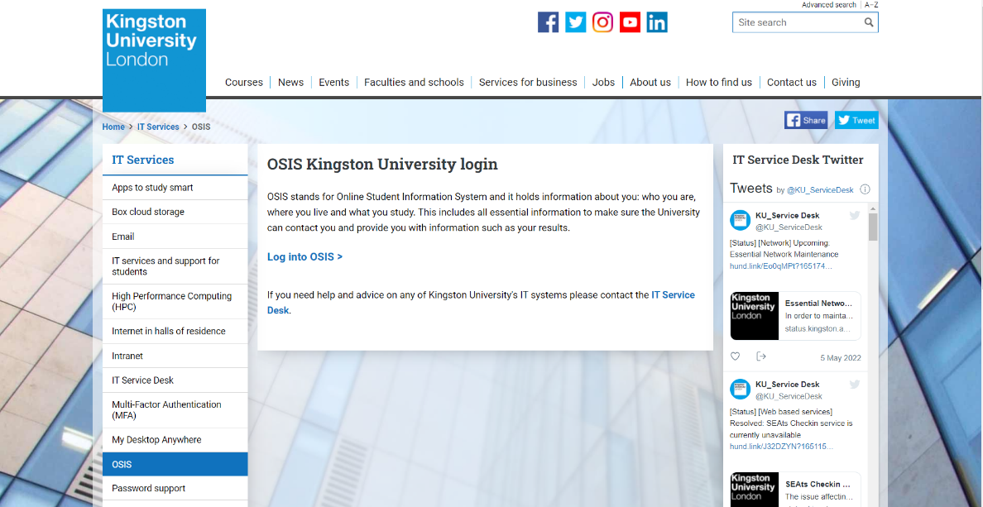

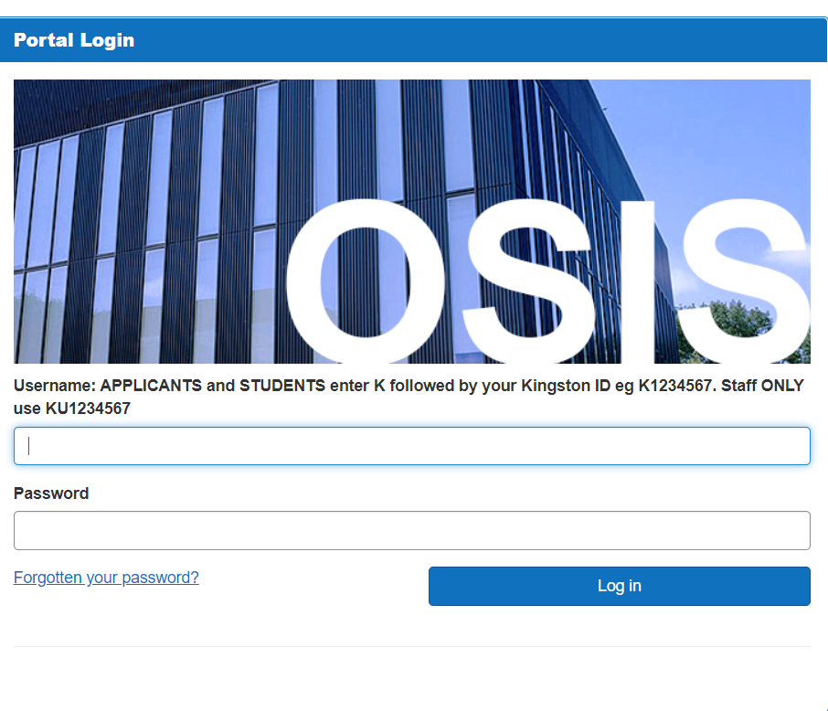

1. **University of Kent:**

This is Kent University's student information portal. This is for the student's personal information, from which they can learn about the course they are taking, their grades in each subject, and much more. To login the page users need college email address.

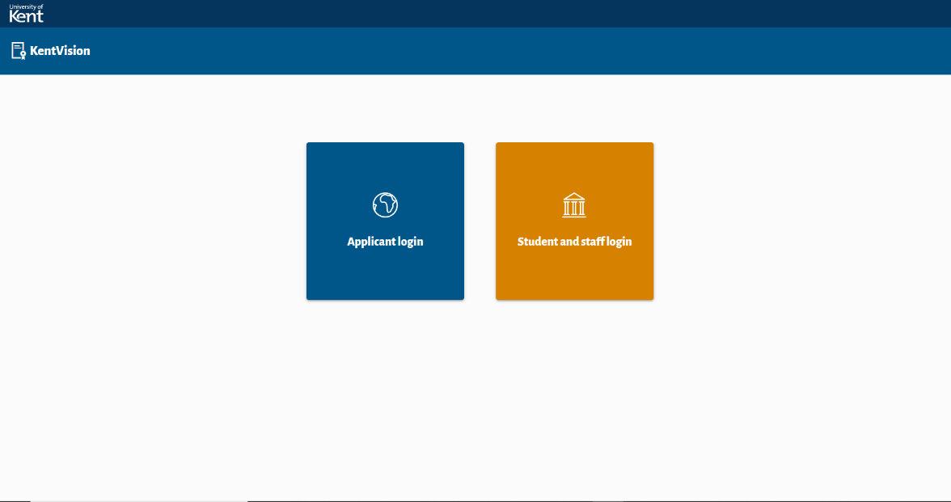

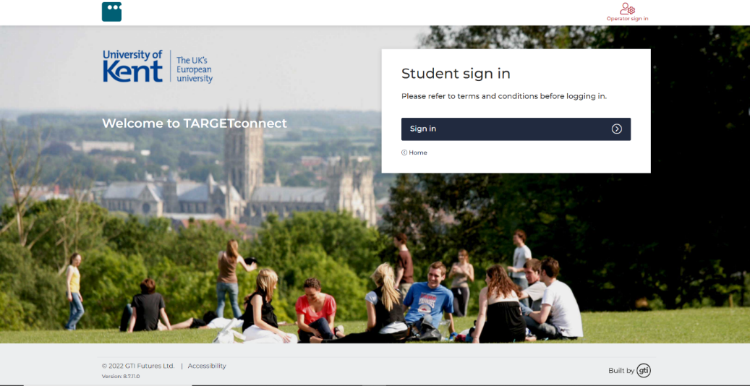

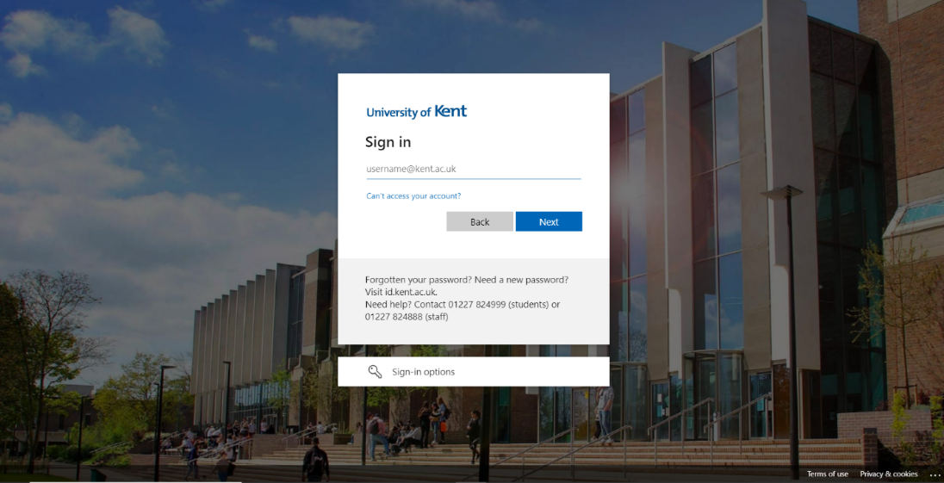

1. **University of Southampton:**

The picture we have displayed below shows the student portal of Southampton University. To login the page you need to get the email address and password from the university after you get enrolled.



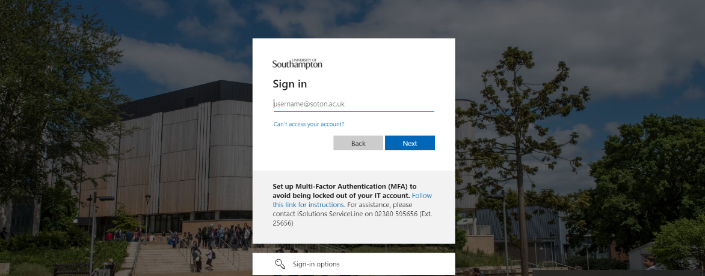

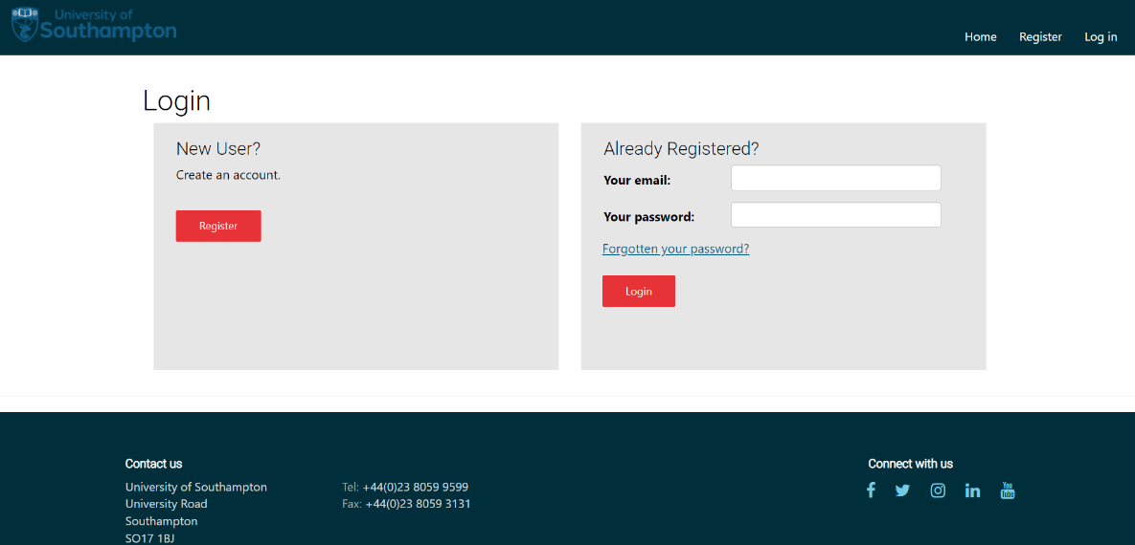

* + - * 1. **Student Records/Information Applications (Mobile Format)**

1. **Kingston University:**

This is the mobile format student portal of Kingston University. You can see a lot of fields being displayed. As you can know about the time management of university through app. You can have Bus timetable with KU bus tracker facility. You can also know about the room number and the floor they are situated in through app.

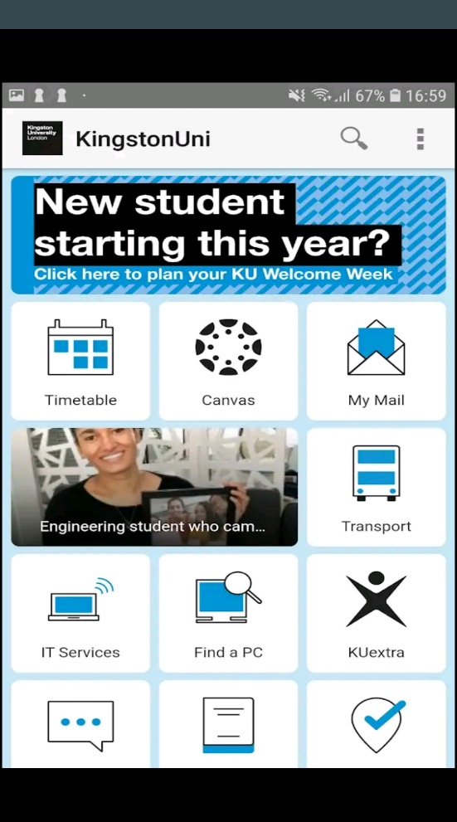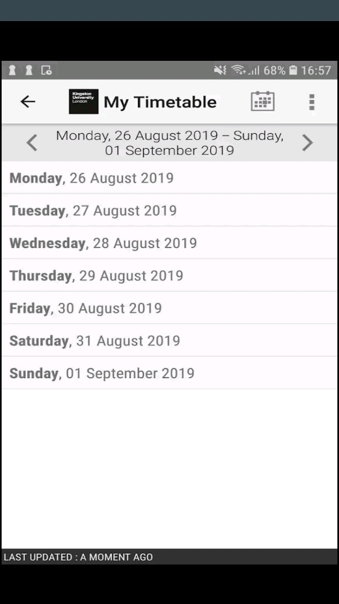

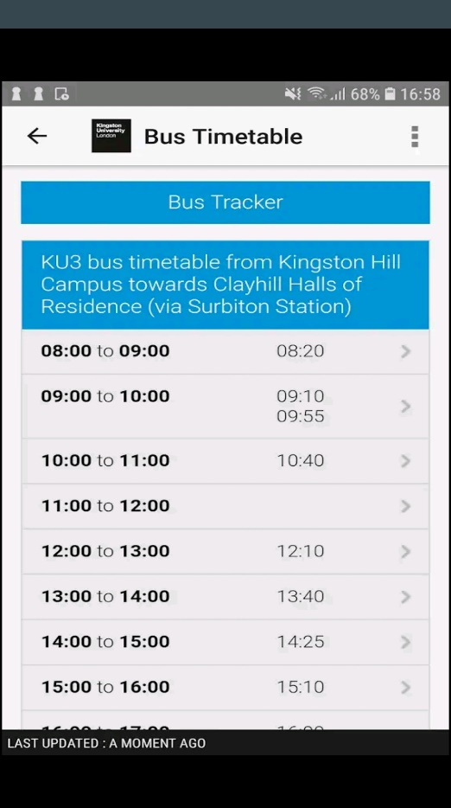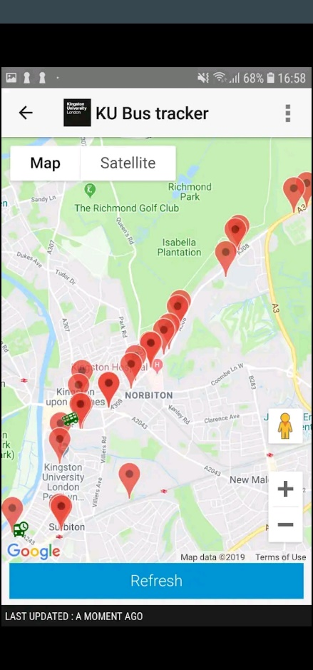

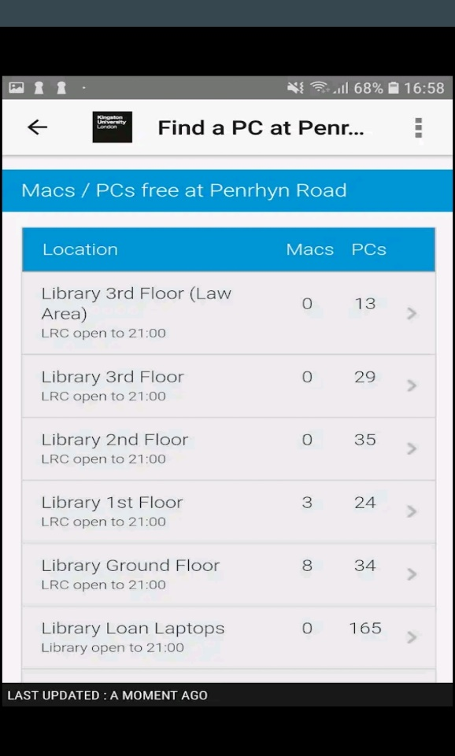

1. **University of Kent:**

This is University of Kent mobile-friendly student portal. Through this app student can know about the time tables of university, course they are enrolled in and the about the events and many more. They can also get the news about the University through the app and connect it through mails and different social sites.

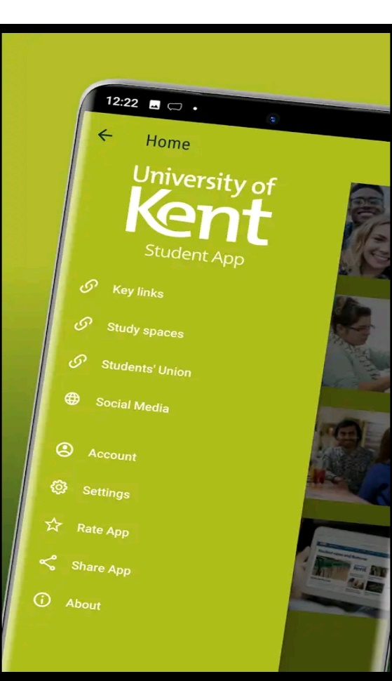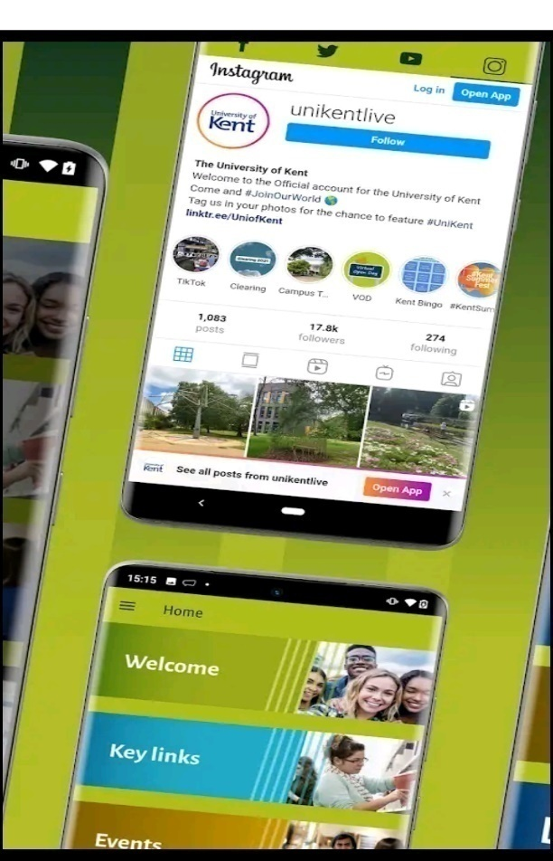

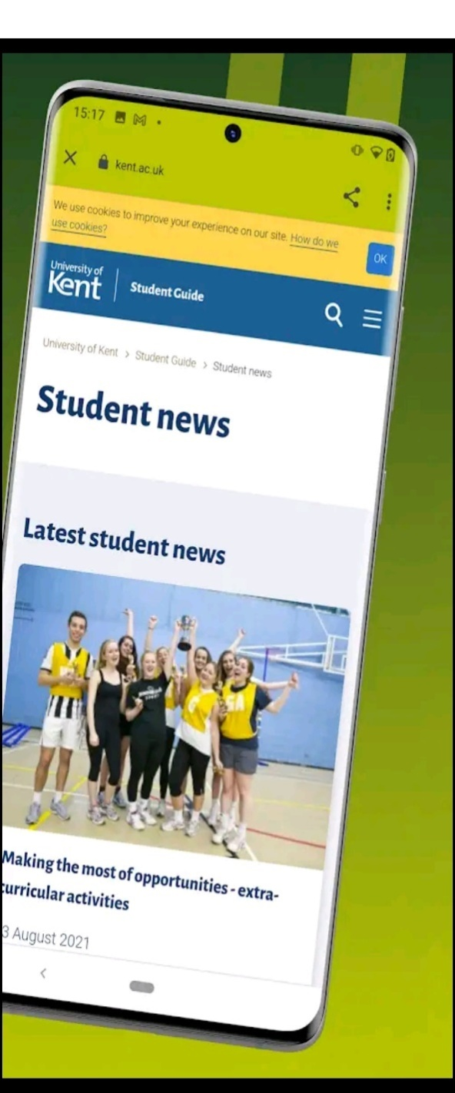

1. **University of Southampton:**

The picture displayed below describes the student portal mobile format view of Southampton University. Through the app student can know about the college premises, bus timetable, sports, news and events.

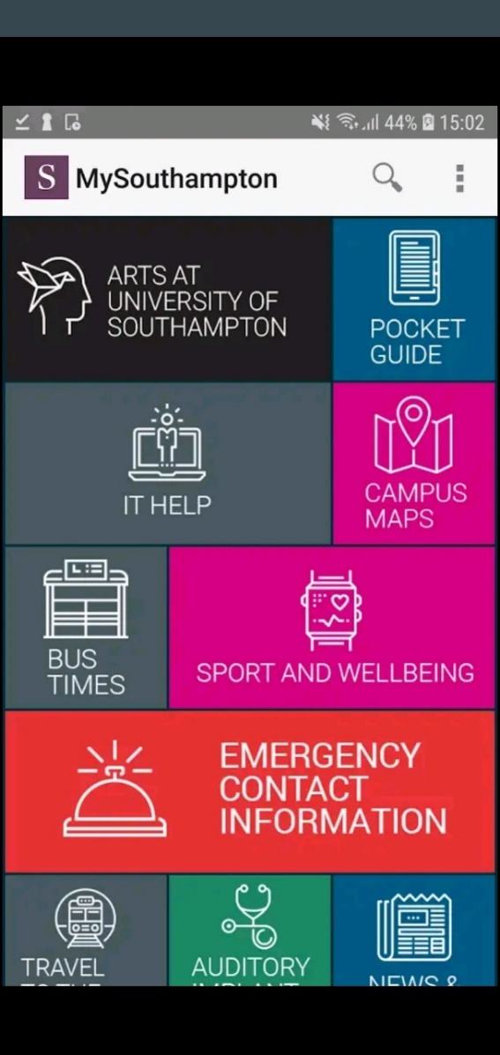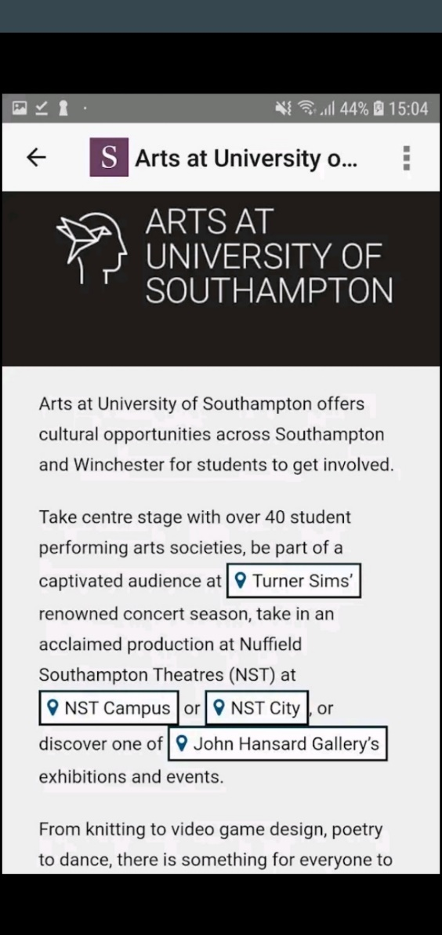

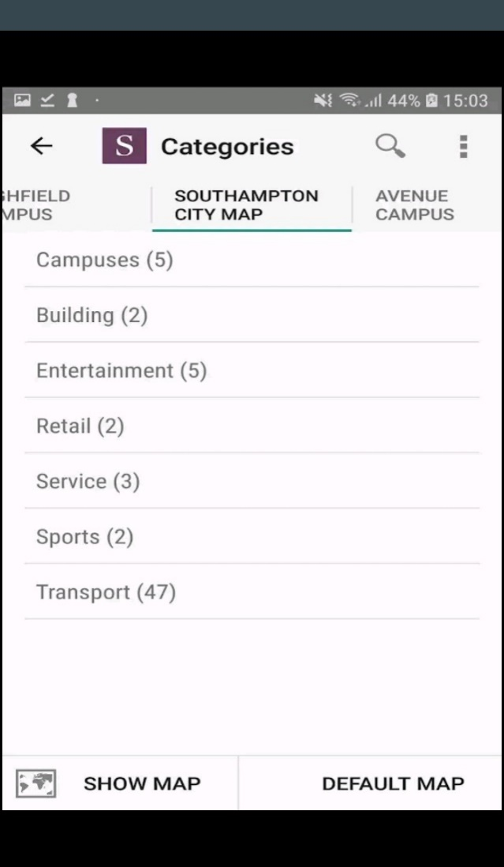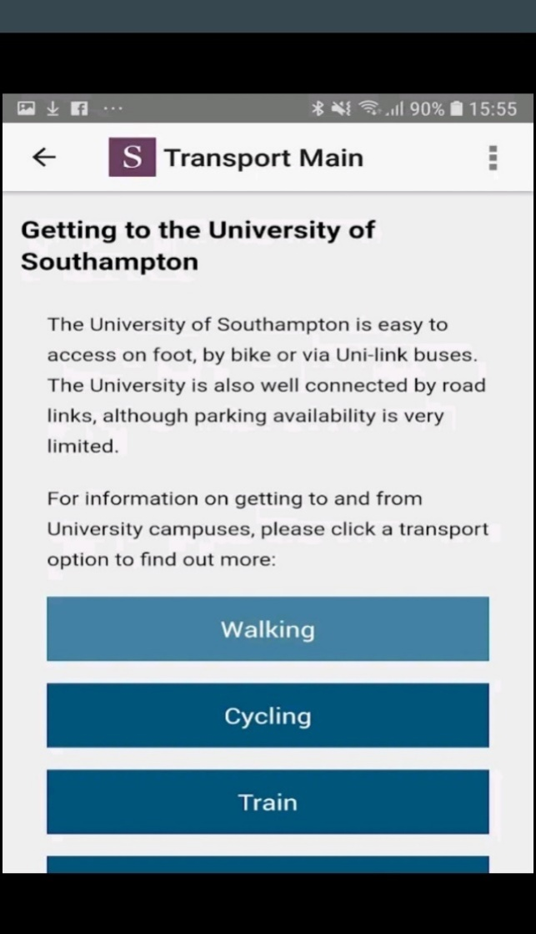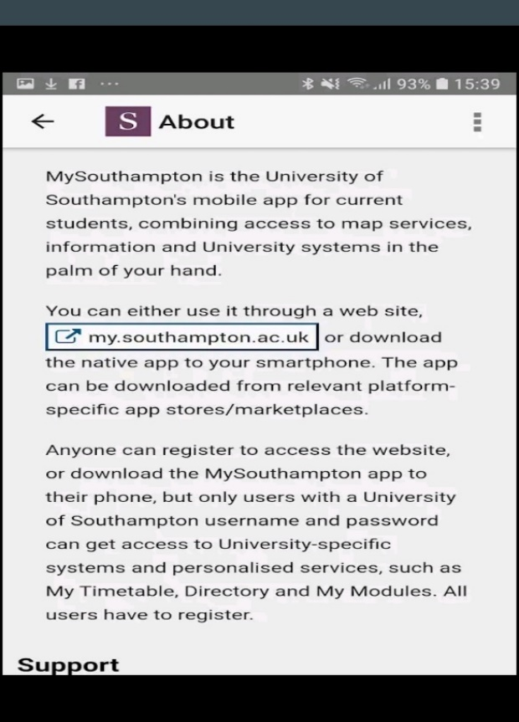

* + - 1. **Development Relevant Legislation**
         1. **Equality Act**

The Equality Act 2010 legally protects people from discrimination in the workplace and society as a whole.It consolidated previous anti-discrimination laws into a single Act, simplifying the law and strengthening protection in certain situations. It outlines the various ways in which it is illegal to treat someone. The following is the policy for using private data stored in the system: (GOV.UK, 2010).

* Allow direct allegations of gender pay discrimination when there is no actual comparison
* preventing pay secrecy clauses from being enforced
* Sex, religion or belief, pregnancy and maternity, and genderreassignment are all protected in private clubs.
* Introduce new authority to the Labour Court to make recommendations that benefit the wider workforce
  + - * 1. **General Data Protection Regulations (GDPR)**

Woodlands University College (WUC)proposed computerized system that contains data on staff, students, and potential members. The information should be used wisely and kept only when absolutely necessary. The Information Assurance Act 2018 establishes rules based on the UK's implementation of the General Data Protection Regulation (GDPR). The following is the policy for using private data stored in the system: (GOV.UK, 2018).

* The use of private data stored in the system should be fair, legal, and transparent.
* The system's private data should only be used for specific, well-defined goals.
* The system should be used in a way that is satisfactory, significant, and limited to only what is necessary.
* Data on the system should be accurate and current as needed.
* Don't keep data on the system for any longer than is absolutely necessary.
* It must be managed in a secure manner, with safeguards against unauthorized or illegal processing, access, loss, destruction, or damage.

According to W3C accessibility evaluation guidelines, the pages should be accessible, navigable, and understandable regardless of any limitations. Individual pages can and must be tested for accessibility using web accessibility evaluation tools.

* + - * 1. **Educational Relevant Legislation**

The federal legislation that oversees the administration of federal higher education program’s goal is to improve our colleges and universities' instructional resources while also providing financial aid to students in postsecondary and higher education.The new system software suggested by Woodland University College (WUC), which holds the student's data and details, should be retained carefully and only when required.

The following is the rule regulating the use of private data maintained inside the system, as stated in the Higher Education and Research Act of 2017:

* It must ensure that the initial registration conditions applicable to an institution
* The institution may access or make arrangements for the assessments
* The length of the period must not exceed the limit specified by the Secretary of State in regulations.
* If the institution has a high level quality rating at the time the plan is authorized, the higher price will be charged; otherwise, the sub-level amount will be charged.
* Academic freedom is granted in terms of determining the content of certain
  + - 1. **Academic Literature Review**

A literature review is a piece of academic writing that demonstrates knowledge and understanding of academic literature on a specific topic. A literature review differs from a literature report in that it includes a critical evaluation of the material.It gives you a broad overview of current knowledge, allowing you to spot relevant theories, methods, and research gaps.Using secondary sources, the researchers discovered that academic literature writing and review follow different patterns and systems depending on the nature and character of the research, writing in contexts, and the study's specific goals; there are various types of literature and writing in academics, and while no single approach is universally accepted at the same time, different approaches are used.

**2.1.3.3.1. Example Project Relevant Research**

Suitability of the Project Research will be conducted to determine the current flaws in the data management system and how the team can address them in order to improve the software. The old method will be improved, and significant changes will occur. This study will aid in the completion of the software.

**2.1.3.3.2 Development Relevant Implications of Research**

The study's implications explain how the findings might affect policy, practice, theory, and future research. The research implications are the conclusions drawn from your findings that show how the findings may have policy, practice, or theoretical implications. The research will uncover the potential effect that can be incorporated into the software to address the current problem.

* + - 1. **User Group Questionnaires**
         1. **Student Experience Questionnaire**
  1. How frequently do you visit the school's website?
  2. Is it possible to find what you're looking for on the homepage of the website?
  3. What information are you looking for on the school website?
  4. What online tools do your teachers use to build their classroom websites?
  5. What is your usual method of accessing the school's website?
  6. Would you use a school-related mobile app?
  7. What features would you like to see added to this product?
  8. Do we live up to your expectations?
  9. What level of satisfaction do you have with your experience?
     + - 1. **Academic Staff Experience Questionnaire**

1. What online tools do youuse to build the classroom websites?
2. What would you use to describe your current employment situation?
3. What would you say about WUC academics?
4. Do we live up to your expectations?
5. What level of satisfaction do you have with your experience?
6. What features would you like to see added to this product?

2.2 Requirements Specification

The requirement specification comprises high-level descriptions for the software's functional and non-functional specifications, as well as use cases that show how a user would interact with the system when it is completed. It is one of the most important documents in software development is the requirement specification. It explains how a software system should be produced and gives everyone concerned a project plan.

2.2.1 Problem Domain Description

The problems and constraints that clerical management systems impose on stakeholder which limits the work efficiency are discussed, along with the best solution for the problem domain approach to tackle the problem:

2.2.1.1 Existing Business Operation

The operations of a company can change from time to time due to various factors. In order to ensure that the founders are aware of the various responsibilities and procedures that go into running a business, a section is included in the company's operations plan. The term business operation refers to the various activities that a company does to keep its operations running smoothly. This section provides a framework for the founders to manage the company's various operations. The operations department of a company is responsible for overseeing all aspects of the company's operations, such as its marketing and sales processes. It is also responsible for keeping track of the company's earnings. When a small business grows, it must be prepared to face additional challenges such as legal, marketing, and capacity difficulties. If the company does not evolve to stay up with changing business processes, errors and omissions will arise. However, in order to make most organizations' operations more successful, the following elements must be considered:

1. A company's goals should be measured in a way that is realistic and actionable. The goal-setting process should involve keeping up with the company's current operations and developing strategies to beat the competition. Management should also set reasonable deadlines and keep up with the changes in the local and national economy.
2. The roles and duties of the employees engaged are determined by the amount of persons required for a certain activity or project. Typically, team members' responsibilities and functions are split among the various members of the company. When it comes to hiring new employees, it's clear that each candidate possesses a distinct set of talents. HR is integrated into a company's operations to ensure that all key processes are covered. Firms must ensure that the correct personnel are in place to do critical jobs.
3. The proper method (process and location) in the right place at the right time: Process is important because it influences production and efficiency, and location is more important to certain firms than others for various reasons. Manual operations that might be automated or work that is already being performed by other departments can cost a company time and money. A home-based consultant might only need a desk, but a pet groomer could need a parking spot, and so on.
4. Internal resource coordination and cooperation: Managing a company's resources, from money to physical goods, and assigning roles and duties in order to benefit with specialized and distinctive business operations are all part of business operations. In order to run effectively and efficiently, a company needs the right number and type of equipment and technology.
5. Developing plans and implementing new technologies and equipment: It is vital to develop strategies that will assist the company in achieving a certain objective, as well as optimal employee utilization. Talented individuals will gain from the initiative, since they will be able to find jobs based on their qualifications. Individuals who have advanced in their technological expertise will be able to find job depending on their qualifications. The use of modern technology and equipment, such as software or the creation of a corporate website, contributes in the achievement of profit through proper plan execution. Some existent business functions include: Performing banking transactions: Completing basic financial activities and keeping records in an office, including money collection, counting, and payout. Establishing good communication and providing upper-level management, as well as coaching and mentoring newcomers, are all important. Take use of a technological advantage In today's high-tech world, where everyone is eager for the latest technology, new product development and user-friendly website advertising are vital. Complaints and compliments must be examined, and changes made as necessary. A long-term branding plan, as well as monitoring and managing third-party participation, should be included.

2.2.1.1.1 Student Life-Cycle

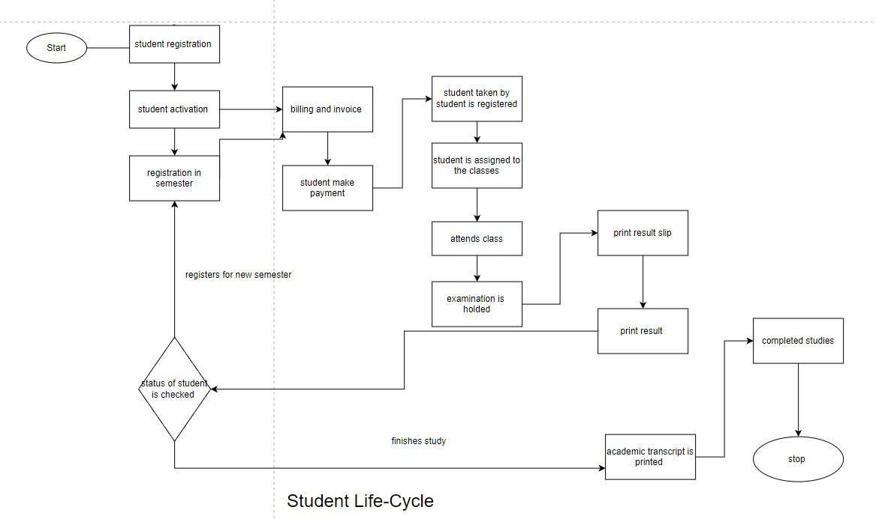

2.2.1.1.2 Personal Tutorial Life-Cycle

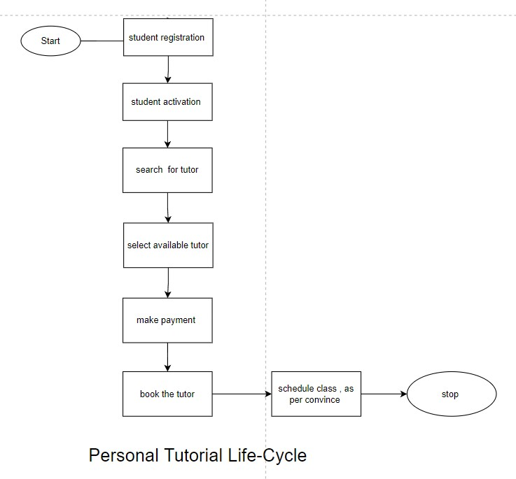

2.2.1.1.3 Optional Process 1

2.2.1.1.4 Optional Process 2

2.2.1.2 Summary of existing business limitations requiring resolution and existing strengths.

The Woodlands University is an existing business that operates on a paper-based system. This university also intends to offer a wide range of degree courses. The issues and problems that were identified during the interview are very serious and must be addressed, which is why the institution intends to develop software and a website, as well as transition from a paper-based to a computerized system.

The following are the most significant downside of current business:

* The university's student, employee, and instructor record management system is purely manual, which is time consuming and tiresome.
* Paper documents are less secure since they can easily be misplaced and fall into the wrong hands, with no way of recovering them.
* The document grows in parallel with the company's growth, resulting in a shortage of space since paperwork grows at the same rate.
* It's possible that students will bribe the teacher to skip the long line.
* There are no adequate methods of communication when events and curriculum activities occur in college.

2.2.2 Functional Requirements

A computation, data manipulation, business procedure, user interaction, or any other specialized capability might be required. Functional Specification is another term for functional requirements in software engineering. A Functional Requirement might be anything from a high-level abstract explanation of the sender's need to precise mathematical functional requirement specifications. The anticipated behavior of the system may be captured using functional software requirements. It refers to a piece of software or a component of one. A function is a collection of inputs, behavior, and outputs for a software system.

*Features required*

* Admin:

1. The system should handle the admission and registration of new students, including their personal information and data.
2. Only the administrator should be able to register new staff, students, and workers by entering their personal information.
3. The scholarships can only be assigned to students by the administrator.
4. Admin should be in charge of seeing and managing the college's financial transactions.
5. Admin should only be allowed to add new users by giving them a login/username and password.

* Tutor:

1. Personal information about employees should be preserved..
2. Staff and student attendance information should be preserved and represented by them.
3. The system should generate the payable salaries of the employees.
4. Teachers should be able to see details about their students as well as update and control their test grades.

* Students:

1. Automated attendance should be taken..
2. The student's personal details should be recorded in full.
3. Individual student grades should be shown on their own login page.
4. Students' fee information should be provided so that they may see how much money is owed to them and how much money they have already paid.

* Course:

1. When students enroll in the new system, they should have access to course details.
2. Every course should have its own name, and each tutor should be able to access their own course.

* Department:

1. The new system should display the department a student is in, how many of them there are, and when they started.

* Scholarship:

1. The new should provide a unique id for each student who has received a scholarship..
2. The details of the scholarship, including how much and when it was awarded, should be given and recorded by the system.

2.2.2.1.1 Records Management Systems

In the table below, the purpose of each relevant field has been presented in a distinct colour to illustrate the possible accessibility:

The course management system's recording activities is seen below:

|  |  |  |  |  |  |
| --- | --- | --- | --- | --- | --- |
| Operation | Super Admin | Admin | Module leader | Tutor | Student |
| Add | Add new student, tutor and staff  information to the data list | Add tutor and student | **No access** | **No access** | **No access** |
| Remove | Able to delete the list of student, tutor and staff the | Make a list of student and tutor | **No access** | **No access** | **No access** |
| Create | Create a new record. | Create a new record. | **No access** | **No access** | **No access** |
| Amend | Change and correct the record details | Change and correct the record details | **No access** | **No access** | **No access** |
| Archive | Move an unnecessary record to archive. | Move an unnecessary record to archive. | **No access** | **No access** | **No access** |
| Delete | Erase the data | Erase the data | **No access** | **No access** | **No access** |
| Display | Display all the list of information about student, tutor and staff | Display all the list of information | Display the list of student and tutor | Show Information about the personnel | Show their personal |
| Assign | Assign the information of newly added animals to the appropriate categories. | Assign the information of newly added animals to the appropriate categories. | **No access** | **No access** | **No access** |
| Attendance | Take a look and can maintain and keep of track of student staff and tutor | can maintain and keep of track of student staff and tutor | can maintain and keep of track of student and tutor | can maintain and keep of track of student | **No access** |
| Assignment | Keep track of given assignment | Keep track of given assignment | Able to update download and edit | Able to update download and edit | Able to see and download |
| Result | Add | Able to view and add | Able Insert | Able to view add and maintain rubric | Only Able to view marks |
| Dairy | Able to edit, create, change | Able to edit, create, change | Able to view ticket details | Manage the ticket sales system | The price of a ticket can be viewed and buy. |
| Search | Add necessary search for animals, events and correct them | Find the necessary animals and events and make the necessary corrections. | Able to search animals and events information | Able to find about the animals. | Search the zoo catalogue using a search engine. |

1. Admin

|  |  |  |  |
| --- | --- | --- | --- |
| Attributes | Type/format | Constraints | Notes |
| admin_id | NUMBER (8) | PK | Primary key for the manager. |
| admin_first_name | VARCHAR2(13) | UPPER | Admin first name. |
| admin_last_name | VARCHAR2(13) | UPPER | Admin Last name. |
| contact_number | NUMBER (30) | NOT_NULL | Admin Contact number. |
| house_number | VARCHAR2(5) | NOT_NULL | Admin House number. |
| City | VARCHAR2(10) | NOT_NULL | The city where the admin resides. |
| country | VARCHAR2(5) | NOT_NULL | The country in which the admin resides. |
| date_of_birth | DATE | NOT_NULL | Admins date of birth. |
|  |  |  |  |

1. Module leader

|  |  |  |  |
| --- | --- | --- | --- |
| Attributes | Type/format | Constraints | Notes |
| module_leader_id | NUMBER (12) | PK | Primary key for the module leader. |
| module_leader_first_name | VARCHAR2(40) | UPPER | module leader first name. |
| module_leader_last_name | VARCHAR2(40) | UPPER | module leader Last name. |
| module_leader_address | VARCHAR2(35) | UPPER | module leader address. |
| Town | VARCHAR2(10) | UPPER | The city where the module leader resides. |
| County | VARCHAR2(10) | UPPER | The country in which the module leader resides. |
| contact_number | NUMBER (45) | NOT_NULL | module leader Contact number. |
| Gender | CHAR | CHECK IN (‘M’, ‘F’), NOT_NULL | The module leader gender. |
| Email | VARCHAR2(40) | UNIQUE | module leader email address. |
| date_joined | DATE | NOT_NULL | The year the module leader became a member of the University. |

1. Tutor

|  |  |  |  |
| --- | --- | --- | --- |
| Attributes | Type/Format | Constraint | Notes |
| tutor_id | Number (10) | PK | Primary key for the tutor. |
| tutor_full_name | VARCHAR2(15) | UPPER | tutor full name. |
| tutor_address | VARCHAR2(20) | UPPER | Tutor address. |
| Email | VARCHAR(10) | UNIQUE | Tutor email address |
| tutor_role | VARCHAR(5) | NOT_NULL | The subject that tutor teaches. |

1. Student

|  |  |  |  |
| --- | --- | --- | --- |
| Attributes | Type/format | Constraints | Notes |
| student_id | NUMBER (10) | PK | Primary key for the student. |
| student_first_name | VARCHAR2(30) | UPPER | Student first name. |
| student_last_name | VARCHAR2(30) | UPPER | Student Last name. |
| student_address | VARCHAR2(40) | UPPER | Student address. |
| Town | VARCHAR2(20) | UPPER | The city where the student resides. |
| County | VARCHAR2(20) | UPPER | The country in which the Student resides. |
| contact_number | NUMBER (25) | NOT_NULL | Student Contact number. |
| Gender | CHAR | CHECK IN (‘M’ , ‘F’) , NOT_NULL | The Student gender. |
| Email | VARCHAR2(30) | UNIQUE | Student email address. |
| date_joined | DATE | NOT_NULL | The year the student enrolled in University. |

2.1.3.1.2 Student Records/Information Portal

|  |  |  |  |
| --- | --- | --- | --- |
| **Attributes** | **Description** | **Type** | **Format** |
| student_ID (PK) | Student ID Number | Int | 11 |
| Student_fname | Student First Name | Varchar | 30 |
| Student_lname | Student Last Name | Varchar | 30 |
| Student_course | Student Course | Varchar | 30 |
| Student_year | Student Year | Int | 11 |
| Student_contact | Student Contact Number | Int | 11 |
| Student_age | Student Age | Int | 11 |
| Sudent_birthdate | Student Birth Date | Date |  |
| Student_gender | Student Gender | Int | 11 |

2.1.3.1.3 Woodlands University College Corporate Website

|  |  |
| --- | --- |
| **Requirements** | **Description** |
| Home page | This page will include a crucial introduction, details, information, university values, and the website's goal. |
| Contact page | This page will include contact information, allowing employees, students, and other interested parties to communicate with the appropriate persons in the appropriate departments. |
| About us | This page will feature the university's information, descriptions, departments, and history. |
| Gallery page | This page contains images and visual information about the institution so that interested parties, staff, and students may learn more about the university's academic environment. |
| Courses | This page provides a comprehensive summary of all of the university's courses and teachers. |
| Events | This website provides historical photographs and visual information from numerous festive events hosted at the institution, as well as information on forthcoming or ongoing events. |
| News | This website contains up-to-date information on the university, its activities, and its students, as well as local and worldwide information relevant to the students or their academic education. |
| Apply | This page allows interested individuals and future students to apply to the university and register for any of the institution's courses and modules. |
| Login | This is the webpage or entry page to the university website that needs user identification and authentication, which is often supplied by the institution to its students and employees in order to keep them informed and provide private information. |

2.2.3     Performance Requirements

A performance requirement is a method for determining how well a software system performs certain tasks under certain situations.

2.2.3.1 Records Management

Records management is a procedure that may be used to govern the development, maintenance, reception, and disposal of information in any format. In other words, it refers to the management of a company's important information from its creation to its disposal.

 The following are the many performance requirements for the smooth and efficient operation of the record management system:

2.2.3.1     Speed

Data Management System

To keep the record management system functioning smoothly, the data management system should be as fast as possible. The data processing time and reaction time should be as short as feasible. In a data or record management system, optimal speed implies that records are processed quickly, efficiently, and smoothly. The record management system should retain speed so that the institution's performance and efficiency do not suffer. The data management system's processing and response times are as follows:

**Processing**: Processing: On the inside, everything should be in order. A request is processed in no more than 5 seconds. The server will timeout in 10 seconds. Consistent reaction time is needed. A mistake can only be accepted for a maximum of three seconds.

**Response time**: The ideal reaction time from pressing any buttons to loading the pages is 4 seconds. A two-second mistake is allowed, and the service will be stopped within ten seconds.

2.2.3.2   Capacity

The capacity of a record management system refers to the amount of workload that the system can handle without being overburdened or damaged.

**System for data management**

The volume of work: This operation has no pressure or load, thus one person should be able to do it.

Data: We need to keep track of a lot of records and data of the staff and students in the university.

 2.2.3.3   Reliability

For any record management system to work in the future the most important thing that it requires is the reliability of its data management system. It should be efficient and work at a constant level under pressure.

**System for data management**

Our information is incredibly safe and user-friendly, thus the system is quite trustworthy. In addition, all of the data is backed up in the cloud. Every three months, you will receive an update. The notification for the servicing break has arrived, and it contains information on how long the repair will last.

2.2.3.4   Usability

The record management system must be simple to operate. It should not take a large amount of labor to operate, and the system's operation should not be overly complicated or require extensive training.

**Data management software**

This strategy is not only simple to apply, but it is also simple to comprehend. This tool should be easy to use for anyone who is acquainted with Microsoft Word, Excel, and Access. This form is easier and handier than paper-based forms. It only takes a few hours to learn.

2.2.3.4   Accessibility

The university's record management system is mostly accessible to administrators, managers, and supervisors. Because of the nature of their employment, which requires them to work all day around records, they are given access to the university's record management system, which allows them to store, manage, maintain, and update records.

2.2.3.2 Student Records/Information Portal

The Student Records/Information Portal is a portal on the website where all of the students' information and data is collected, such as their address, the course they are taking, their grades, their course tutors, and so on. This portal assists in the methodical and orderly organization of all student data and allow employees to rapidly discover information about any student.

The following are the numerous performance requirements for the Student Records/Information Portal's seamless and efficient operation:

2.2.3.2.1 Speed

Data Management System

Since the system must sift through the information on thousands of students at the institution, the data management system must be swift and efficient to keep the Information Portal running properly. Data processing and reaction times should be as quick as possible and should not be delayed. Optimal speed in the Student Information Portal means that data about students is handled fast, efficiently, and seamlessly. The institution's effectiveness and efficiency should not be harmed by the information portal's slowness. The following are the processing and response times for the data management system:

**Processing**: Everything should be in order on the inside. A request for a student's data should take no more than 5 seconds to process. In 10 seconds, the server will timeout. A consistent response time is required. For a maximum of three seconds, a mistake can be tolerated.

**Response time**: The recommended response time is 4 seconds from hitting any buttons to loading the pages. A two-second error is acceptable, but the service will be terminated within 10 seconds.

 2.2.3.2.2    Capacity

The quantity of data or information that an Information portal can store and process without becoming overwhelmed or destroyed is referred to as its capacity.

**Data management System**

The quantity of work: Because there is no strain or demand on this procedure, one staff member should be able to complete it.

Statistics: Thousands of students (i.e. from 2000 and above) graduate and enter schooling each year, and we need to keep track of their information and data. The students' information is extensive, ranging from race, ethnicity, nation, and age to blood group and classes.

2.2.3.2.3 Reliability

The most critical requirement for any Student information portal to function in the future is its dependability. In terms of student data management, the student portal system should be dependable, secure, and efficient. The student information portal should have a specific level of security so that students' privacy may be protected and sensitive and private information can be kept secure. This necessitates the data management system's dependability. Data handling should be quick, efficient, and consistent even when under duress.

**Data management system**

The data saved should be extremely secure and user-friendly, allowing the system to be demonstrated to be fairly reliable. Furthermore, all data should be backed up to the cloud. The students that are involved receive an update every three months. If there is any difficulty or problem, the servicing break notification should occur, along with information on how long the repair will take.

 2.2.3.2.4   Usability

Because the Student Information Portal System will be utilized by both students and staff, it should be simple to use and the user experience should be prioritized. This method should not necessitate the employment of excessive personnel, and the handling process should be simple and require little training to operate.

**Data management System**

In addition to being easy to use, this method is easy to understand as well. Anyone familiar with Microsoft Word, Excel, and Access should have no problem utilizing this program. As opposed to paper-based forms, this one is simpler and more convenient. A few hours is all it takes to learn it.

2.2.3.2.5 Accessibility

The administration and then the course leaders have access to the student portal. Due to the nature of the job, the admin has the greatest access to the student portal. They have the ability to authenticate the student's identification and information, as well as change or delete the information from the system. The course leader may also be granted limited access to the student database in order to verify or obtain information about a specific student.

2.2.3.3 Woodlands University College Corporate Website

Following is a synopsis of the website we were requested to create. The technological requirements for our university's website are shown below. We'll go through all of the website's features and what kind of help we can get in this piece.

The following are the many performance requirements for the smooth and efficient operation of the Woodlands University College Corporate Website:

2.2.3.3.1 Speed

The total success of a website is determined by its speed. Slow website performance will always have a negative impact on search engine optimization and Google ranking. The first impression a potential student has of your website is its speed. This website's performance should be speedy and efficient, as it symbolizes the university's brand and academic atmosphere. It should not lag or produce sluggish results. The webpage should take less than two to three seconds to load. It should concentrate more on the user experience in order to get credibility. The corporate website should be of the greatest quality and speed. It should run smoothly and fast to be perceived as professional and trustworthy.

2.2.3.3.2 Capacity

A website is a system, and we should conceive of it in terms of "throughput" rather than "capacity." As a result, rather than a total number of visitors (capacity), you'll require a visitor rate per unit of time (throughput). The website's average intake must equal its average outflow for optimal efficiency. Hundreds of students and staff will use the website every day to look for information, thus it should not be slow and have a large capacity.

2.2.3.3.3 Reliability

Since it is a corporate website, it should have excellent information, be updated on a regular basis, be simple to navigate, and have a high visitor-to-student conversion rate. The website must be trustworthy and safe. The website's information should be secure and user-friendly, allowing the system to be trusted. Furthermore, all data should be backed up to the cloud.

2.2.3.3.4 Usability

The corporate website should be simple to navigate. Because the majority of its users will be ordinary people, it should be simple to use. It should not be very complicated or need a large number of people to run, and it should not require any training. In addition to being simple to use, the material on the website should be simple to comprehend. The system should be user-friendly and show all university information in a straightforward and fascinating manner so that viewers' interaction with the website increases and they learn more about the institution.

 2.2.3.3.5 Accessibility

Everyone has access to the Woodlands University College Corporate Website. Anyone interested in continuing their education at this institution can examine the information and galleries on the Woodlands University College corporate website, which is open to the public. The website is an excellent source of advertising for any future potential students who may be interested in the school's courses and amenities. History or the grounds.

2.2.4 Design Constraints

Non-functional requirements that impact (constrain) how the system is created but not what the system does are known as design constraints. Design constraints are design limits. These include enforced limits over which you have no control and self-imposed limitations used to enhance a design.

2.2.4.1 Records Management Systems

* Target Operation System: The main aim of this project is to provide record management system where they can store, manage and maintain the record details of this institution.
* Hardware requirement:

1. Operating system: windows 8 or later
2. Processor:  Minimum 1GHz
3. Ethernet connection (LAN) OR a wireless adapter (Wi-Fi)
4. Hard Drive: Minimum 64 GB is required

2.2.4.2 Student Records/Information Portal

* Target Operation System: The main aim of this project is to provide record management system of student where they can store, manage and maintain the student record with information portal details of this institution.
* Application package: SQL
* Design Approach: For the mock-up layout, we used a software program referred to as figma.com and for wireframe layout of the system we used diagrammatic approach.
* Font-end graphic style: The system is built using a consistent company format.

2.2.4.3 Woodlands University College Corporate Website

* Target Operation System: The main aim of this project is to provide record management system where they can store, manage and maintain the record details of this institution.
* Design Approach: For the mock-up layout, we used a software program referred to as figma.com and for wireframe layout of the system we used diagrammatic approach.
* Font-end graphic style: The system is built using a consistent company format.
* Programming language: HTML, CSS, JavaScript and Java are the programming language that has been used to create the system.

2.2.5 Commercial Constraints (Total Project)

Basic commercial constraints like time and budget are taken into account to assist potentially complex cost/time scale calculations, a range of project management strategies have been created.

|  |  |  |  |
| --- | --- | --- | --- |
| Project information |  |  |  |
| Total length of project | 77 days |  |  |
| Hourly wage | £150 per person |  |  |
| Number of workers | 6 |  |  |
|  | |  |  |
| Project breakdown |  |  |  |
| Section | Weeks | Hours per week per person | Total wage |
| Requirement specification | 1 | 2 | £5000 |
| Design and analysis | 2 | 3 | £10589.05 |
|  |  |  |  |
| Project built breakdown | 3 |  |  |
| Console | 30% | 2 | £60000 |
| Website | 25% | 6 | £100000 |
| Student information portal | 10% | 6 | £98050 |
| Testing | 30% | 4 | £45000 |
| Evaluation | 5% | 7 | £30000 |
|  |  |  |  |
| Additional cost |  |  |  |
| Reason | Cost |  |  |
| Software/hardware | £750500.40 |  |  |
| Office cost (£100 per week) | £65000.25 |  |  |
|  |  |  |  |
| Total built cost | £ 5,090,000 |  |  |
|  |  |  |  |
| Other expenses (10%)  Profit margin (30%)  Profit rights | £3526.77  £5480.32  Negotiable |  |  |
|  |  |  |  |
| Total project cost | £ 6,500,000 |  |  |

**2.2.6 Acceptance Tests (Total Project)**

1. **System Analysis & Design (Records Management System)**

The system analysis and design documentation are included in this section. The system will be built using the PHP MVC architecture, with database access, user views, and logical aspects of the web application separated. All of the data will be stored in a MySQL database.

**3.1 Preliminary Design Stages**

**3.1.1 Textual Analysis**

Expected classes and their behaviors will be highlighted through textual analysis. This is based on the brief, documents, and workshops that have been provided.

|  |  |
| --- | --- |
| Area | Notes/Essential Functionality |
| Student Records | Add_student, Edit_student, Delete_student, Change_status, Login, Logout, Change_password, Archive. |
| Lecturers | Add_lecturer, Edit_lecturer, View_lecturer, Delete_lecturer, change_password, Login, logout |
| Administrator | Add_ administrator, Edit_ administrator, View_ administrator, change_password, hide_Administrator, remove_Administrator, Login, logout, |
| Course Records | Add_course, Edit_course, View_course, Change_course, Delete_course, Archive. |
| Module Management | Add_module, Edit_module, View_module, Change_status, Delete_module, Archive. |
| Assignment Management | Add_assignment, Edit_assignment, View_assignment, Change_assignment, Delete_assignmetn, Archive, Add_assignmentgrade, Edit_assignmentgrade |
| Attendance Records | Add_attendance_records, Edit_ attendance_records, View_attendance_records, Change_ attendance_records, Add_absent_present |
| Personal Tutor Management | Add_tutor, Edit_tutor, View_tutor, change_status,search_ module, view_ module, hide_module, remove_ module |
| Timetable Management | Add_timetable, Edit_timtable, Create_timetable, View_timetable,Change_timetable ,Delete_timetable, View_timetable. |
| Diary Management | Add_Diary, Edit_Diary, Create_Diary, View_Diary, |

**3.1.2 Significant Event Analysis**

|  |  |  |
| --- | --- | --- |
| Event | Performers | Attributes |
| Login | Administrator, lecturer, Student, Personal tutor | ID, password |
| Logout | Administrator,lecturer, Student, Personal tutor | - |
| Change Password | Administrator, lecturer, Student, Personal tutor | ID |
| View Administrator | Administrator, Staff, Student | ID, full name, status |
| Add Administrator | Administrator | Full Name, Email, Password, status |
| Edit Administrator | Administrator | Full Name, Email, Password, status |
| Delete Administrator | Administrator | ID |
| View Student (Backend) | Administrator, Staff, Student | ID, full name, status |
| Add Student | Administrator | Full Name, Email, Password, status |
| Edit Student | Administrator | Full Name, Email, Password, status |
| Archive Student | Administrator | ID |
| Delete Student | Administrator | ID |
| View Lecturer | Administrator | Lecturer_id,Lecturer_fullname, Contact_no, Email, Address |
| Add Lecturer | Administrator | Lecturer_id,Lecturer_fullname,Contact_no, Email, Address |
| Edit Lecturer | Administrator | Lecturer_id |
| Delete Lecturer | Administrator | Lecturer_id |
| View Course (Backend) | Administrator, lecturer, Student | ID, code, name, description |
| Add Course | Administrator | Module, description |
| Edit Course | Administrator | Module, description |
| Delete Course | Administrator | ID |
| View Module (Backend) | Administrator, lecturer , Student | ID, Course name, description |
| Edit Module | Administrator | Description |
| Delete Module | Administrator | ID |
| View Assignment | Administrator, lecturer, Student | - |
| Add Assignment | Administrator, lecturer | ID, Dateline, Module, Grades |
| Edit Assignment | Administrator, lecturer | Dateline, Grades |
| Delete Assignment | Administrator, lecturer | ID |
| View Attendance | Administrator, Lecturer, Student | - |
| Add Attendance records | Administrator | ID, Student_Id, Year, Level |
| Publish result | Administrator | Assignment_id,Module_id,Student_id,Marks, Year,Level |
| Add tutor | Administrator | ID, Course, Student |
| Assign tutor | Administrator | Student_id |
| Edit tutor | Administrator | Lecturer_id, Student_id, module_id |
| Delete tutor | Administrator | ID |
| Add timetable | Administrator | Course |
| Edit timetable | Administrator | Course, Student |
| Delete timetable | Administrator | ID |
| Add diary | Administrator | ID, Event, News, Activities |
| Edit diary | Administrator | - |

**3.1.3 Commands Queries and Constraints.**

* **Administrator**

|  |  |  |  |
| --- | --- | --- | --- |
| **Class** | *Administrator* | | **Part:**1/3 |
| **Type of object:**  An administrator Object. | | **Author: Rabindra Joshi**  **Created: 2022/05/08** | |
| **Queries** | ID, Full Name, Password, Email, Status | | |
| **Commands** | Login, Logout, Add, Edit, Change Password, Archive, Delete | | |
| **Constraints** | * The password must be at least 8 characters long. * The administrator has complete control. | | |

* **Tutor:**

|  |  |  |  |
| --- | --- | --- | --- |
| **Class** | *Staff* | | **Part:**1/3 |
| **Type of object:**  University Staff Object. | | **Author: Rabindra Joshi**  **Created: 2022/05/08** | |
| **Queries** | ID, Full Name, Password, Email, Status | | |
| **Commands** | Login, Logout, Add, Edit, Change Password, Archive, Delete | | |
| **Constraints** | * At least one Active Administrator is required. * The password must be at least 8 characters long. * Student cannot access to staff directory. * Tutor can view student information | | |

* **Student**

|  |  |  |  |
| --- | --- | --- | --- |
| **Class** | *Student* | | **Part:**1/3 |
| **Type of object:**  University Student Object. | | **Author:**  **Created:** | |
| **Queries** | ID, Full Name, Password, Email, Status | | |
| **Commands** | Login, Logout, Add, Edit, Change Password, Archive, Delete | | |
| **Constraints** | * At least one Active Administrator is required. * The password must be at least 8 characters long. * The administrator has complete control. * Staff cannot access to student directory. * Student can only view. | | |

* **Course**

|  |  |  |  |
| --- | --- | --- | --- |
| **Class** | *Course* | | **Part:**1/3 |
| **Type of object:**  A course object | | **Author:**  **Created:** | |
| **Queries** | ID, Course Name, Description | | |
| **Commands** | Add, Edit, View, Change, Display, Delete, Archive | | |
| **Constraints** | * Student must be enrolled in course * Criteria should be fulfilled to study ahead. | | |

* **Module**

|  |  |  |  |
| --- | --- | --- | --- |
| **Class** | *Module* | | **Part:**1/3 |
| **Type of object:**  A module object | | **Author:**  **Created:** | |
| **Queries** | ID, Module Name, Module leader | | |
| **Commands** | Create, Amend, Delete, Archive, Display, Assign | | |
| **Constraints** | * Student should be enrolled in any course * Module leader needed to be enrolled | | |

* **Assignment**

|  |  |  |  |
| --- | --- | --- | --- |
| **Class** | *Assignment* | | **Part:**1/3 |
| **Type of object:**  An assignment object | | **Author:**  **Created:** | |
| **Queries** | Module_Name, Student_ID | | |
| **Commands** | Add, Edit, View, Change, Display, Delete, Archive | | |
| **Constraints** | * Should be submitted in time * Must not be NULL | | |

* **Attendance**

|  |  |  |  |
| --- | --- | --- | --- |
| **Class** | *Attendance* | | **Part:**1/3 |
| **Type of object:**  An attendance object | | **Author:**  **Created:** | |
| **Queries** | Student_ID | | |
| **Commands** | Create, Amend, Archive, Monitor, Display, Action Poor Attendance. | | |
| **Constraints** | * Student should be enrolled to course and come to class | | |

* **Timetable**

|  |  |  |  |
| --- | --- | --- | --- |
| **Class** | *Timetable* | | **Part:**1/3 |
| **Type of object:**  An timetable object | | **Author:**  **Created:** | |
| **Queries** | Course_ID, Student, Event_ID | | |
| **Commands** | Create, Amend, Archive, Monitor, Display, Action Poor Attendance. | | |
| **Constraints** | * Event should not be Null * Course should not be Null | | |

* **Personal Tutor**

|  |  |  |  |
| --- | --- | --- | --- |
| **Class** | *Personal Tutor* | | **Part:**1/3 |
| **Type of object:**  A Personal tutor object | | **Author:**  **Created:** | |
| **Queries** | Tutor_ID, Full Name, address , Email | | |
| **Commands** | Create, Amend, Assign, Display | | |
| **Constraints** | * Personal tutors are not permitted to choose students. * One student cannot have more than one personal tutor. | | |

**3.2 Detailed Static System Designs**

**3.2.1 First Draft BON System Architecture Diagram**

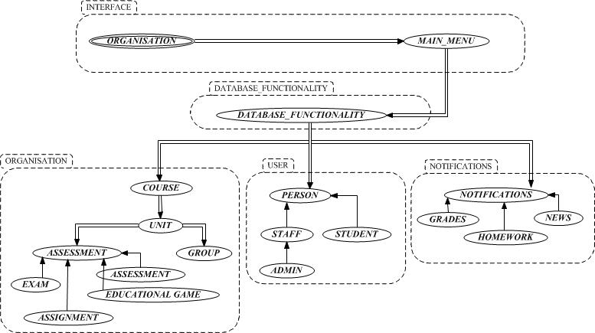

**3.2.2 BON System Chart**

|  |  |  |  |
| --- | --- | --- | --- |
| **System** | *Record Management System (RMS)* | | **Part:**1/3 |
| **Purpose:**  System keeping record of all the staff, members, visitor’s and animals of the zoo | | **INDEXING**  Keywords:Student, staff | |
| **Cluster** | Description | | |
| Staff_Record | Store the data of all the staff of the University | | |
| Student_Record | Store the data of all the student enrolled in the University and the history of the student | | |
| Event | Store the data of event that has been organized and the upcoming events. | | |

|  |  |  |  |
| --- | --- | --- | --- |
| **System** | *Student Records/ Information Portal* | | **Part:**2/3 |
| **Purpose:**  System that holds information about student | | **INDEXING**  Keywords:Student, Course | |
| **Cluster** | Description | | |
| Profile | Brief description about the student | | |
| Course | Information about course he/she enrolled in | | |
| Grades | Marks scored in all the module | | |
| Diary | Upcoming exam or any event schedule | | |

|  |  |  |  |
| --- | --- | --- | --- |
| **System** | *Woodlands University Corporate Website* | | **Part:**3/3 |
| **Purpose:**  System to make a visiting experience more entertainment | | **INDEXING**  Keywords: | |
| **Cluster** | Description | | |
| Login | To login as a staff or student | | |
| Course | Course description with its time period | | |
| News and Event | Galley of events being conducted and update on daily news of university | | |
| Visit | To visit college premises | | |

**3.2.3 BON Cluster Charts**

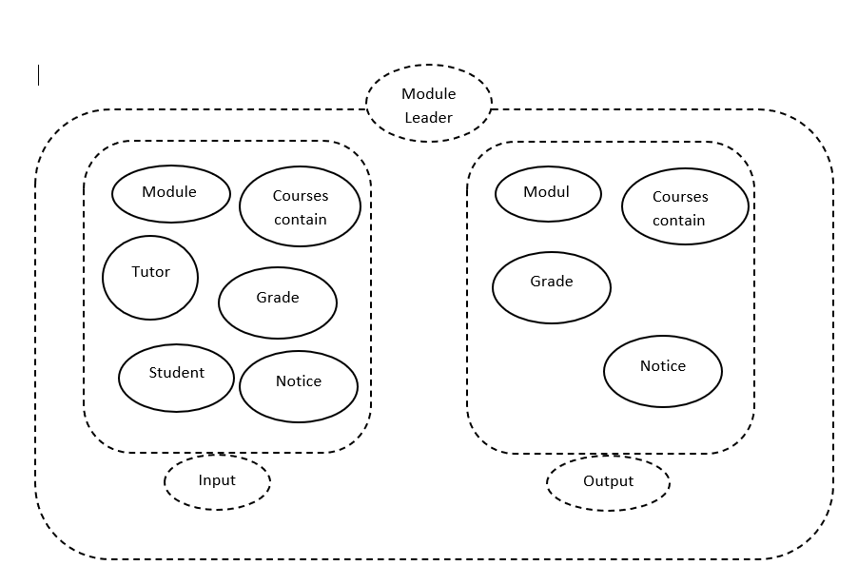

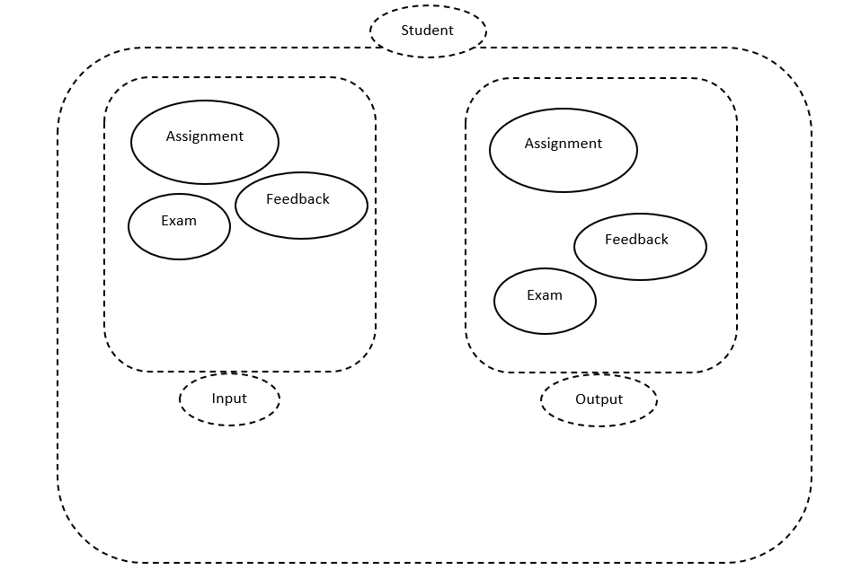

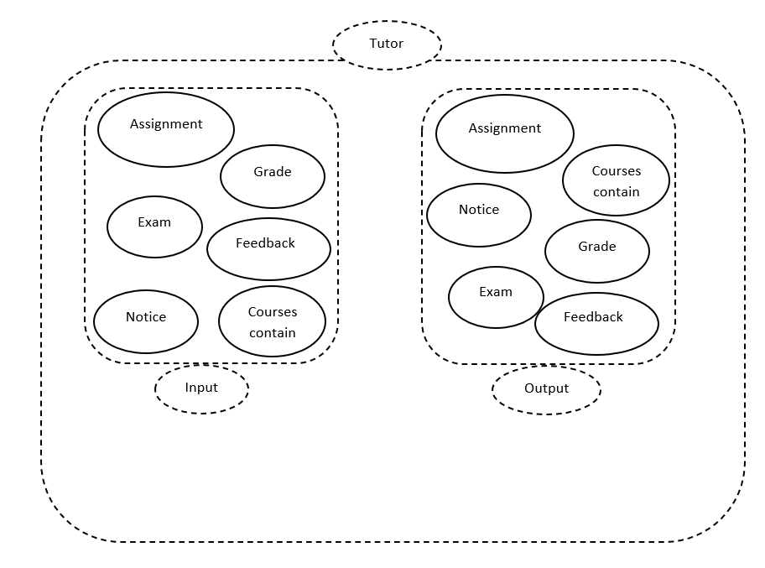

**3.2.4 BON Class Charts**

* **Staff:**

|  |  |  |  |
| --- | --- | --- | --- |
| **Class** | *Staff* | | **Part:**1/1 |
| **Type of object:**  University Staff Object. | | **Indexing cluster:**University Application  **Created:**2022/05/08 | |
| **Queries** | Staff_ID, Full Name, Address, Password, Email, Job Post | | |
| **Commands** | Create, Amend, Archive, Display, Assign, Print, Search | | |
| **Constraints** | * Staff_ID, Full Name, Address and staff post cannot be Null. * Must be employed by organization. * A staff Id must be assigned at the start of employment, numbers auto-increment and are never reused. * Must have student assigned to them. * Must teach at least one unit and/or add unit lesson information. | | |

* **Student**

|  |  |  |  |
| --- | --- | --- | --- |
| **Class** | *Student* | | **Part:**1/1 |
| **Type of object:**  Student enroll on the course | | **INDEXING CLUSTER:** University Application  **Created:** 11/05/2022 | |
| **Queries** | Student_ID, Full Name, Address, Password, Email, Status | | |
| **Commands** | Create, Amend, Archive, Display, Assign, Print, Search | | |
| **Constraints** | * Student_ID, Full Name and Address cannot be null * Must meet entry requirements for course. * Must be enrolled at the university. * Must be assigned to least one unit. * A student ID number is assigned at creation, numbers auto-increment and never recycled. | | |

* **Course**

|  |  |  |  |
| --- | --- | --- | --- |
| **Class** | *Course* | | **Part:**1/1 |
| **Type of object:**  A course object | | **INDEXING Cluster:** University Application  **Created:**11/05/2022 | |
| **Queries** | Course ID, Course Name, Description, Course Leader, Staff_ID, Students assigned | | |
| **Commands** | Create, Amend, Display, Delete, Archive | | |
| **Constraints** | * Course details are set by client * Course code is assigned at certain stage; format set by the client. * Course codes are not recycled, they are unique identifier. * Students cannot be enrolled on a course more than once * A course must have achieved the basic requirements necessary to be on the course * Each course must have a course leader. | | |

3.3 Detailed Dynamic System Designs

3.3.1 Events Charts

3.3.2 Object Creation Charts

3.3.3 System Scenario Charts

3.3.4 Dynamic Diagrams

**3.4 System Database Design**

**3.4.1 E-R Model**

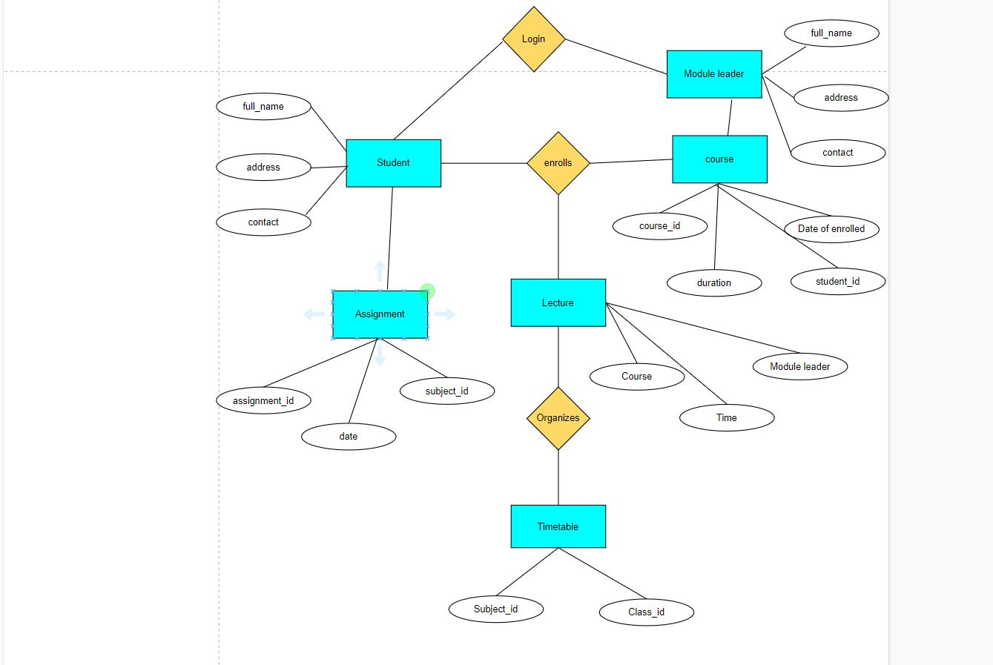

**3.4.2 Attribute Listings**

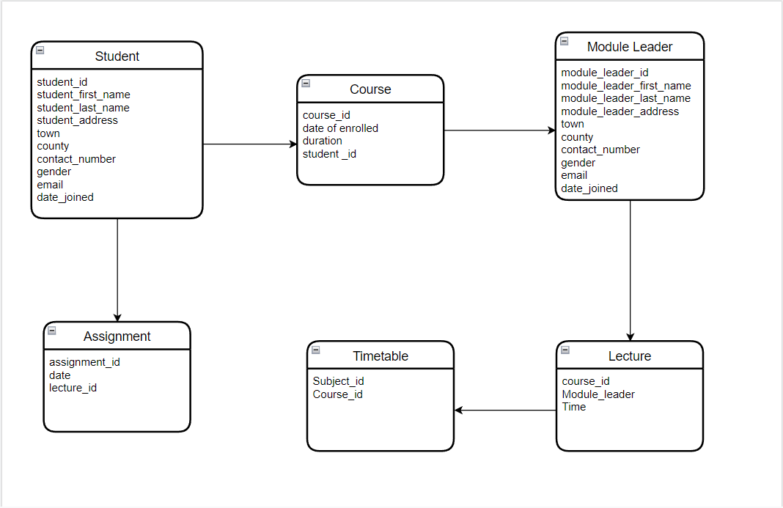

**4. System Interface Designs**

System Interface design fundamental objectives are to design and create systems that are effective, intuitive, and fulfill the needs of a group of users. A user, system, interface, and designer are all involved by definition.

There are two parts to planning the framework interface. One is to plan client interfacing, and the moment is to plan to interface that interface with other frameworks, which are both basic to the system's working.

This section contains wireframes/mockups created as part of the system interface design process, which leads to the real system building and execution.

4.1 Draft Interface Designs (Records Management)

4.1.1 Wireframes

4.1.2 System Navigation Diagram

4.1.3 System Screen mock-ups

4.1.4 System Activity Event Diagrams

4.2 Design Revisions (Records Management)

4.3 Heuristic Evaluation (Records Management)

4.4 Draft Interface Designs (Student Records/Information Portal)

4.4.1 Wireframes

4.4.2 System Navigation Diagram

4.4.3 System Screen mock-ups

4.4.4 System Activity Event Diagrams

4.5 Design Revisions (Student Records/Information Portal)

4.6 Heuristic Evaluation (Student Records/Information Portal)

4.7 Draft Interface Designs (Woodlands University College Corporate Website)

4.7.1 Wireframes

A wireframe is a two-dimensional depiction of a page's interface that focuses on content priority and space allocation, as well as existing features and planned actions. Because of this, wireframes seldom incorporate any style, color, or images.

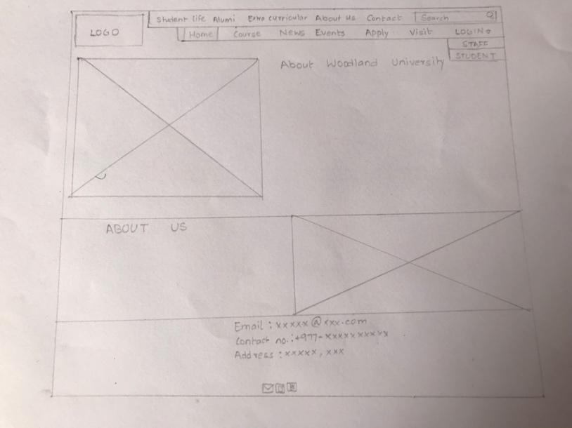

Fig 1 – Wireframe of Home page

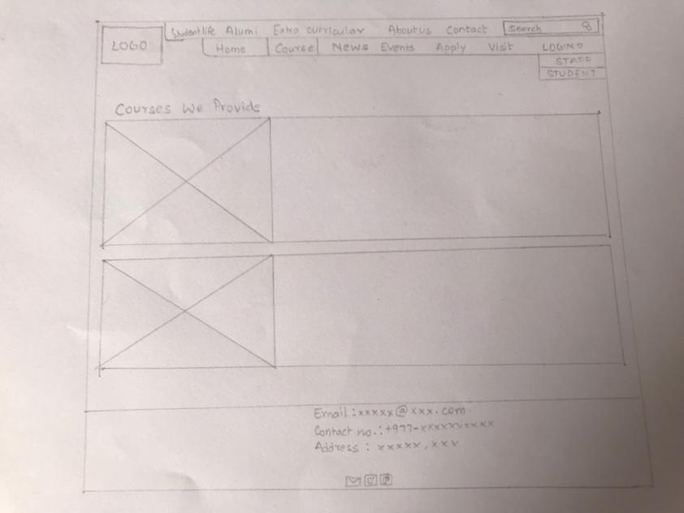

Fig 2 – Wireframe of Course page

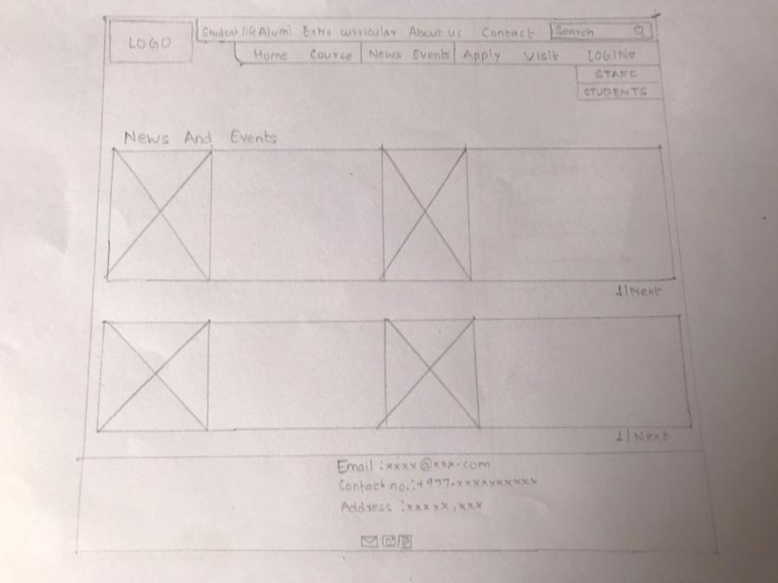

Fig 3 – Wireframe of News and Events page

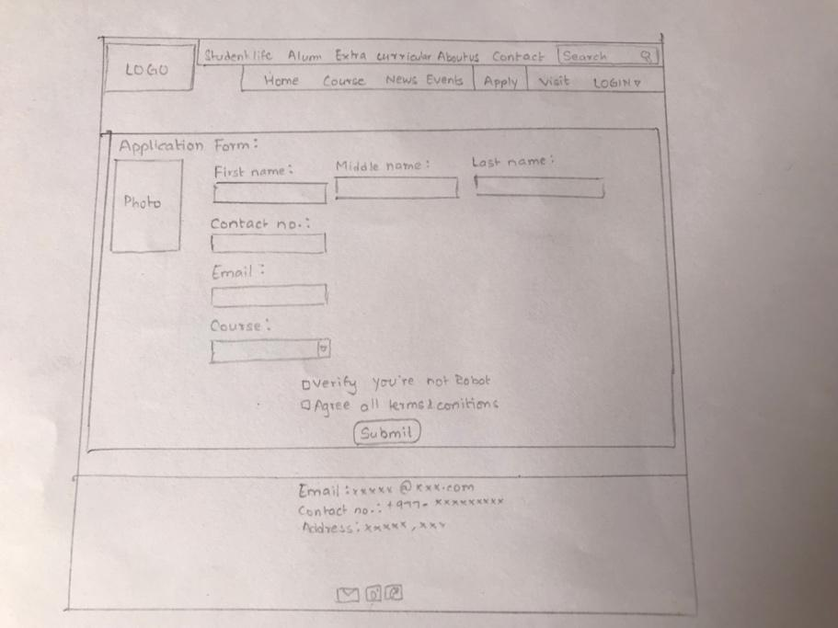

Fig 4 – Wireframe of Apply page

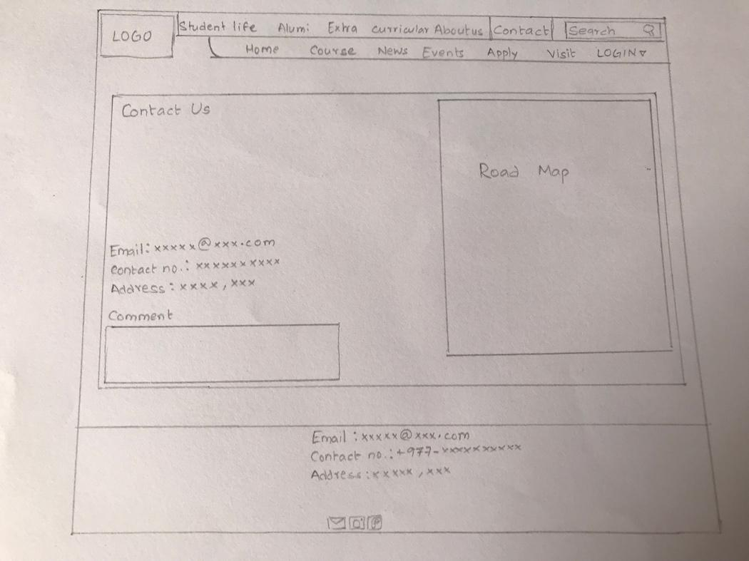

Fig 5 – Wireframe of Contact page

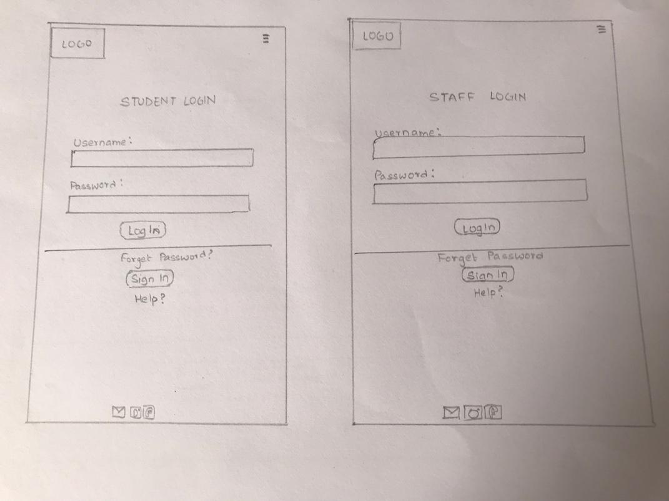

Fig 1 – Wireframe of Login page

* + 1. System Navigation Diagram

This section will include some activity charts for key business events in the system. Similar or repetitive types of events will not be shown more than once.

**Frontend:**  
  
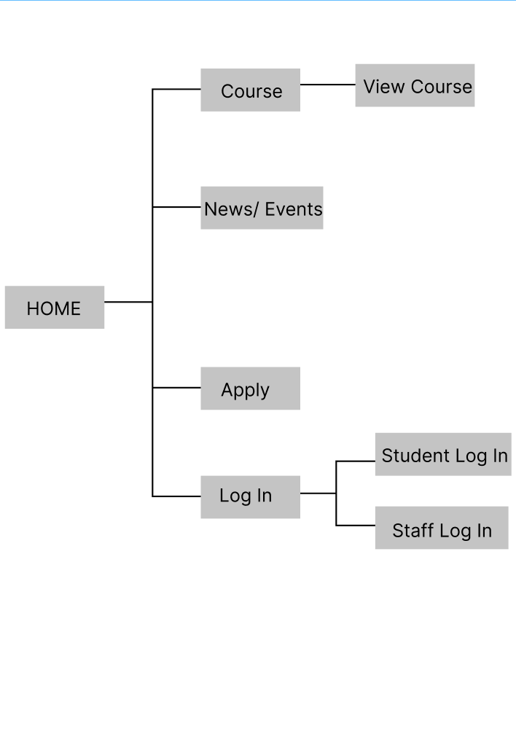

4.7.3 System Screen mock-ups

In each page we have included, the University's logo appears at the top-left corner of the website. In addition, the logo part of the website has a link to the homepage.The navigation bar, is situated on the top left side of the page. It is linked to all of the website's important parts and include a search box that allows visitors to search a website for relevant content. And it also has login drop down list for staff and student login. In the footer, it has included other important information to help the visitor to continue to use the site and basic contact information and social share links which allows visitor to share with others on social networking sites.

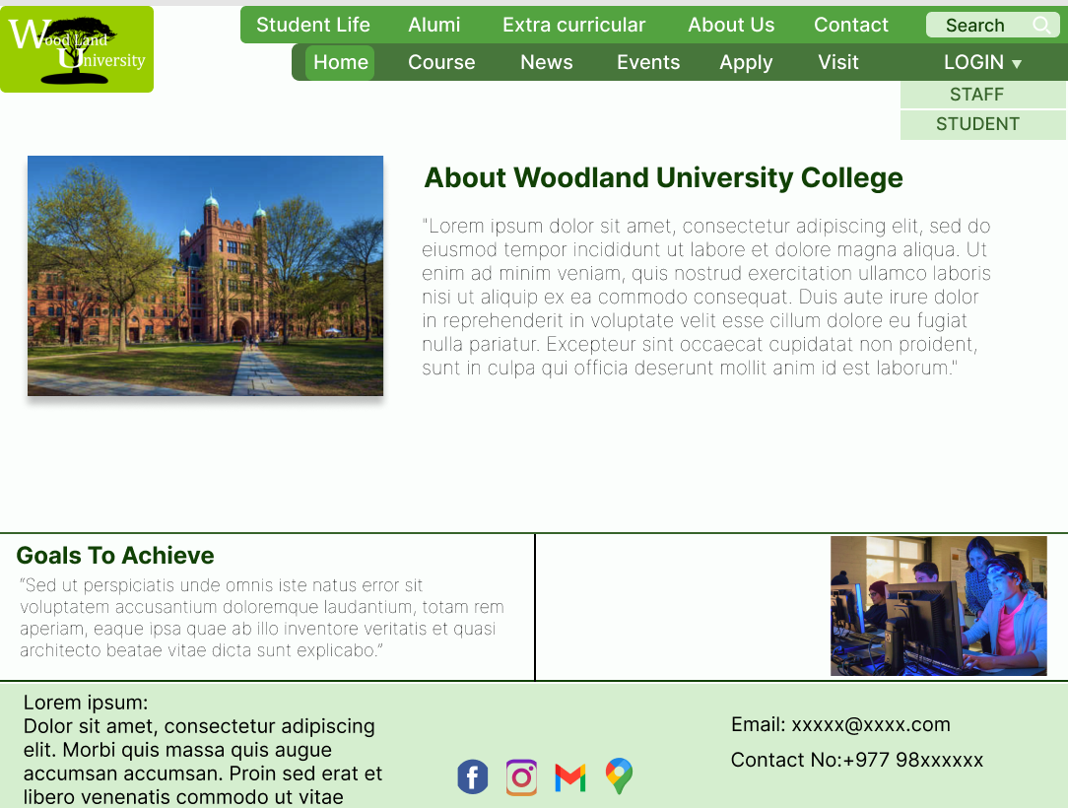

Fig1 - Home page mockup

In the left side, there is a of the University and on the right side of the page it has the information about the University. In the rectangular box, it has included the information the University has to achieve and has pictures of the students.

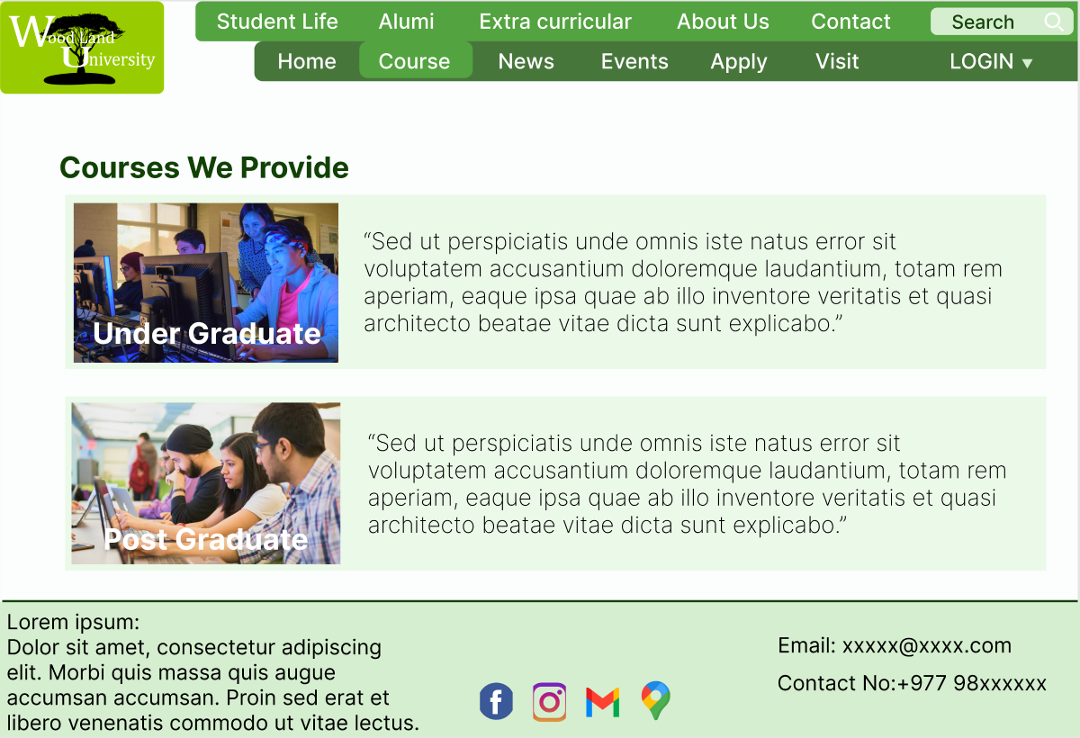

Fig 2 - Course page mockup

In this page, there is the information about the courses that the University provides. It has been divided into two parts as Undergraduate and Post graduate courses.

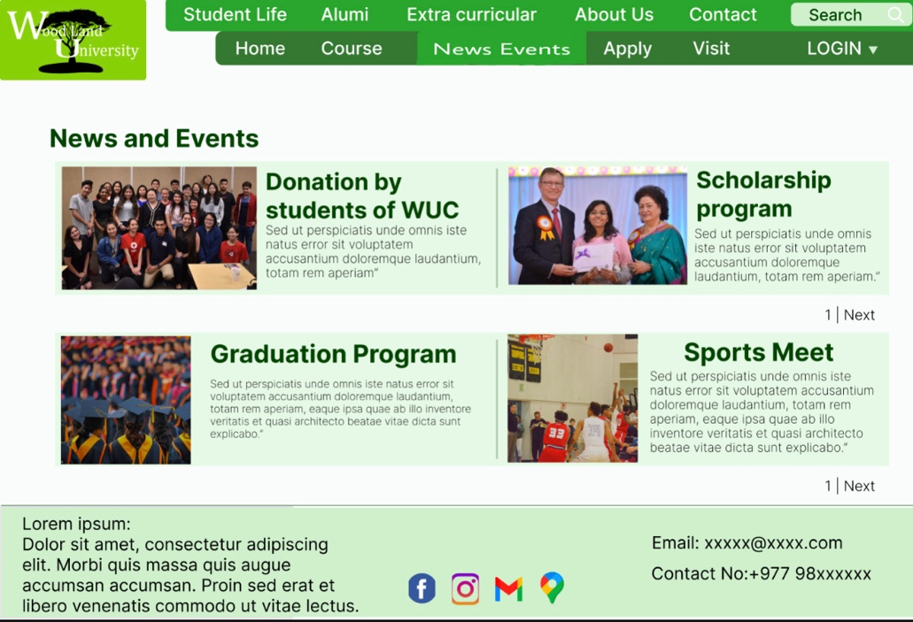

Fig 3 – News and Events page

In this page, there is the list of the events or upcoming events which University has organized and news about the University and Students. By clicking on the next, you can see more news and events of the University.

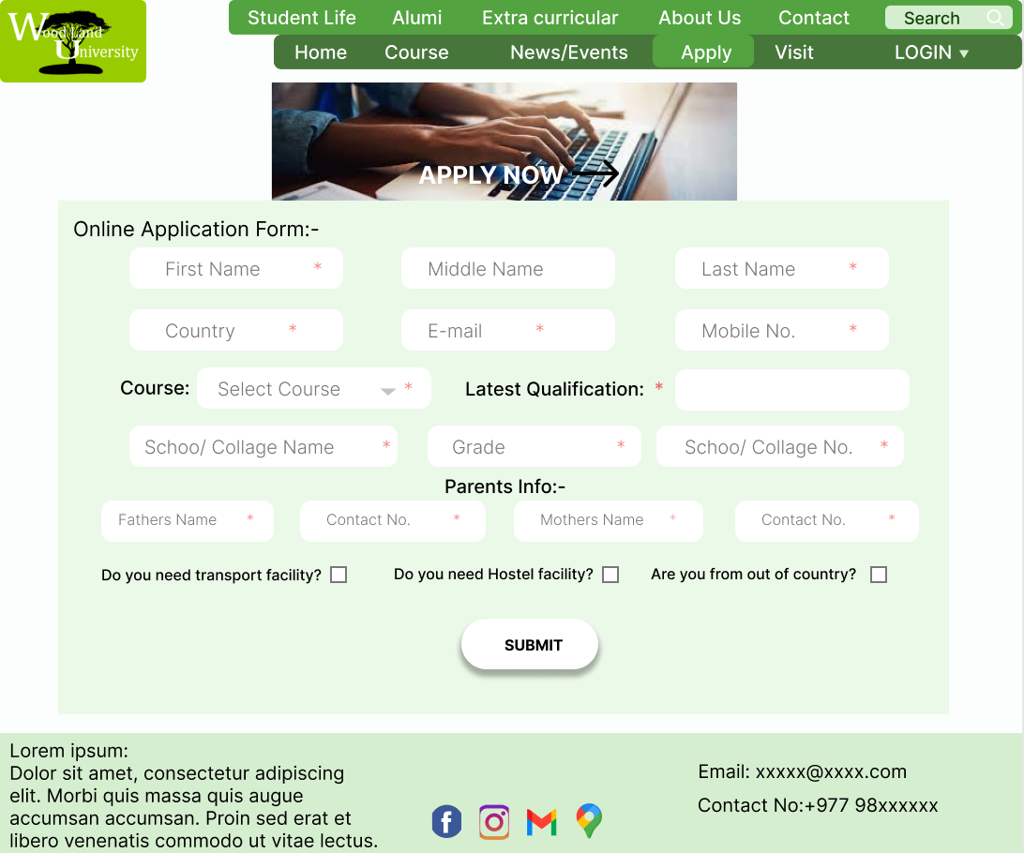

Fig 4 –Apply page

In apply form, students who are interested to study or are interested in Woodland University can fill up the form and can get appointment through his/her email and must agree to all the terms and conditions present in the page.

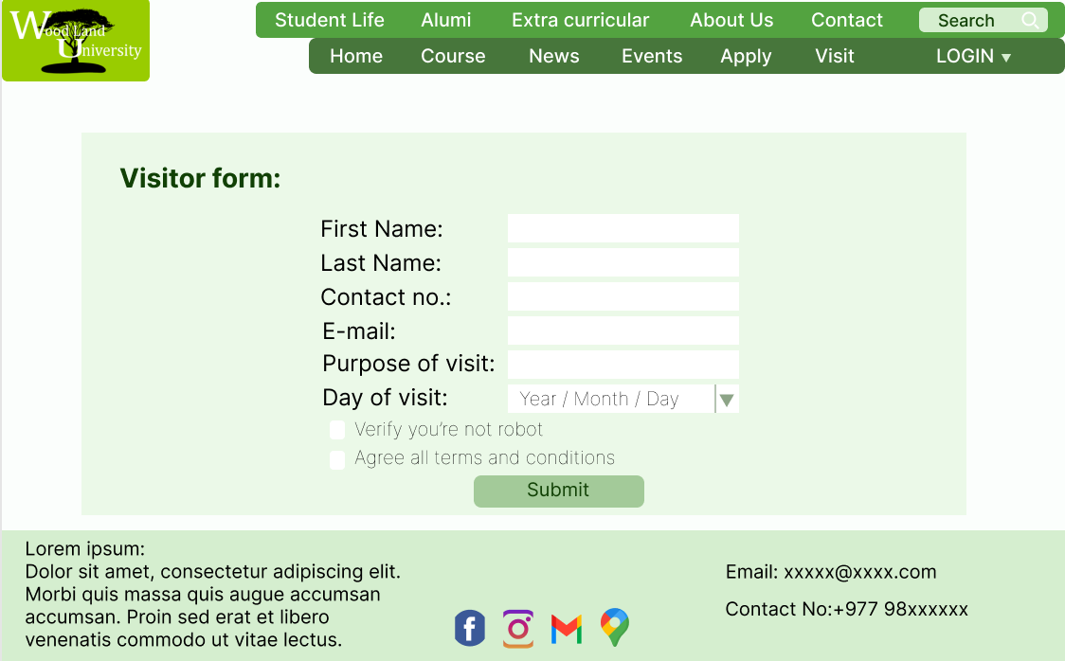

Fig 5 – Visitor form page

In visitor’s form, people who are interested to visit the Woodland University must fill every information present in the form and must agree to all the conditions applied in the page.

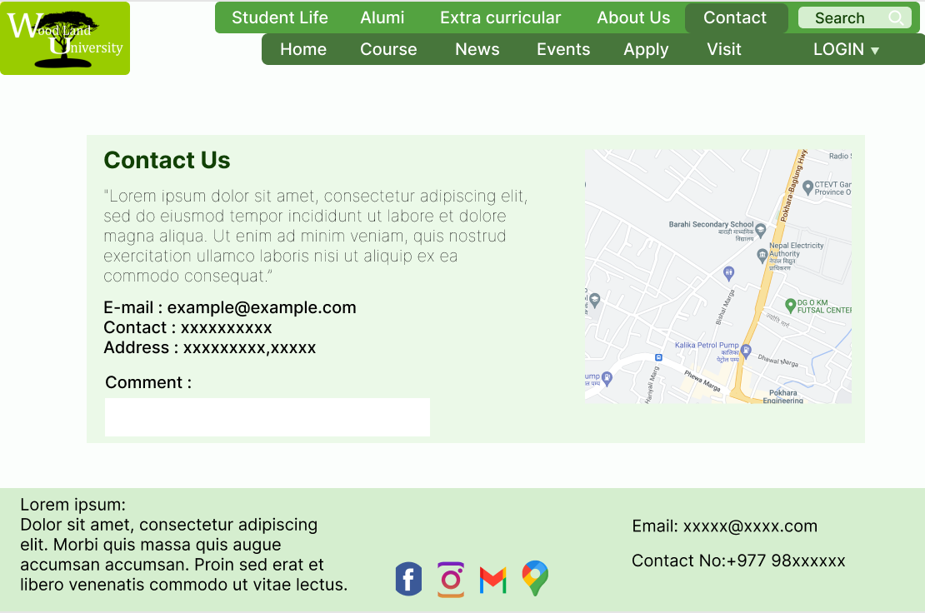

Fig 6 – Contact page

In this page, there is the contact information about the college and the road map of the college.

On the bottom, there is the comment section where visitors of the website can drop his/her remarks/ suggestion about the University and the webpage.

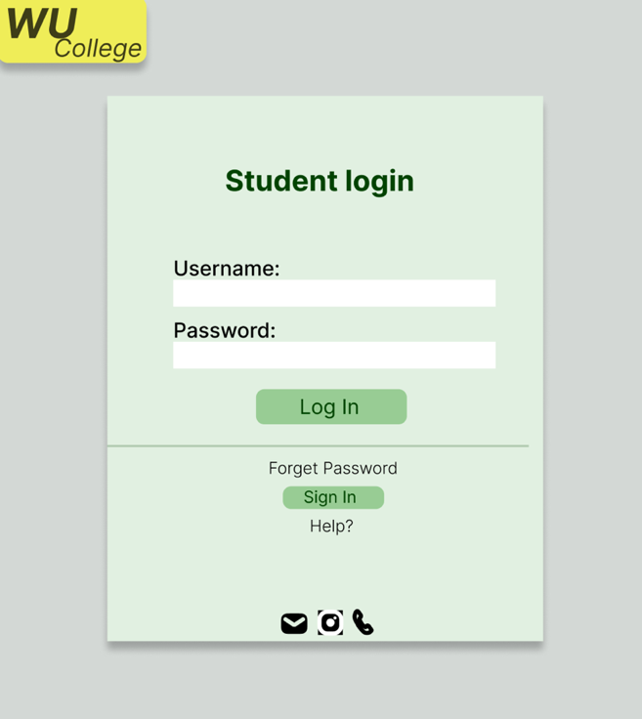

Fig 7.1 – Login page for Student

This is the student login page which is linked with the student portal site.

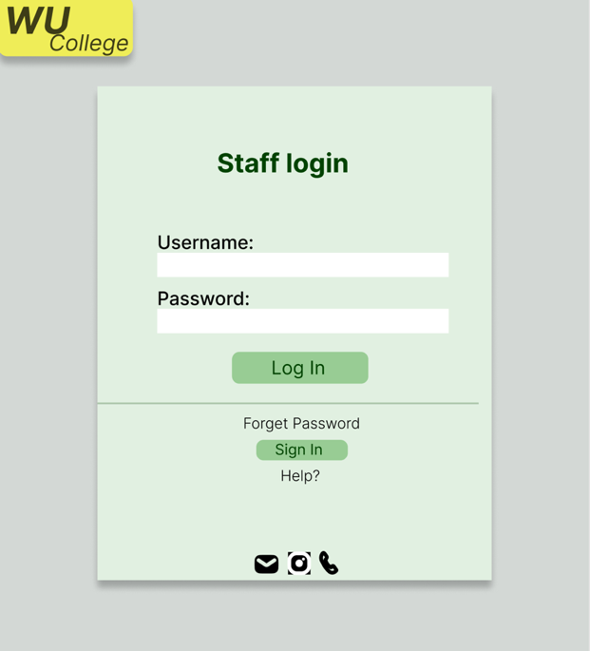

Fig 7.2 – Login page for Staff

This is the staff login page which is linked with the staff portal site. There are two types of

Staff login; admin and teacher.

4.7.4 System Activity Event Diagrams

The flow of activity through a sequence of actions is depicted in the activity diagram. The activity diagram is a useful tool for describing the system.

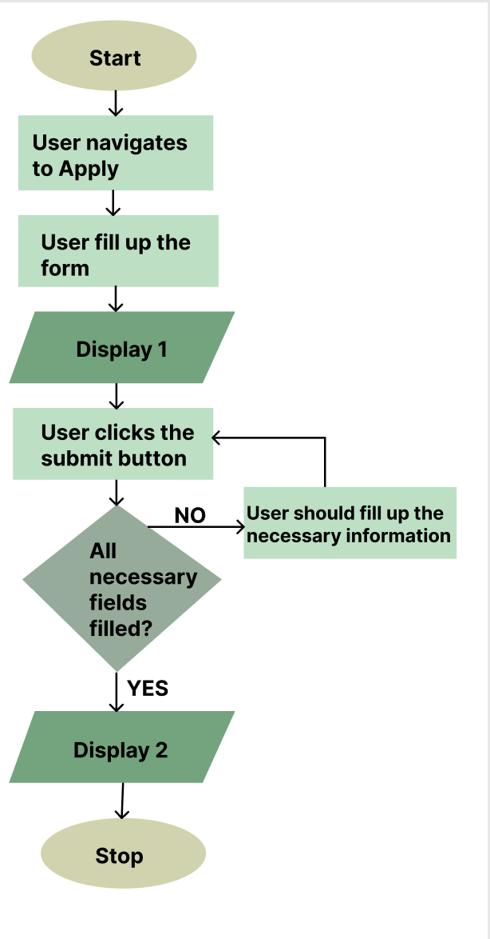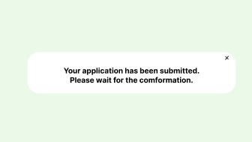**Display 2**

Application form navigation diagram

4.8 Design Revisions (Woodlands University College Corporate Website)

???????????????????????????????????????????

??????????????????????????????????/

?????????????????????????????????????//

??????????????????????????????????????/

???????????????????????????????????//////

4.9 Heuristic Evaluation (Woodlands University College Corporate Website)

Experts utilize rules of thumb to assess the usability of user interfaces in separate walkthroughs and report flaws in heuristic evaluation.

|  |  |  |
| --- | --- | --- |
| **Usability Criteria** | **Evidence** | **Comments** |
| **Color** |  | For both frontend and backend, the template uses a similar and uniform color scheme. |
| **Consistency/ Perceived Stability** |  | The use of the same template across all related pages ensures consistency. |
| **Comment Box** |  | For input, a comment box is given with the usage of messages. |
| **Buttons** |  | Buttons are utilized regularly throughout the system and have comparable design elements. |
| **Icons** |  | People with language difficulties can use icons to navigate. |

5 System Build and Technical Notes

5.1 Technically Difficult Code Sections (RMS)

5.1.1 Timetable Slot Allocation Routines (Feature)

-- Code Example

-- Annotation

-- Why the example is considered to be technically sophisticated

5.1.2 Feature 2

5.1.3 Feature 3

5.1.4 Feature 4

5.2 On-going Testing Methodology (1-2 Pages)

5.3 Final System Interface Displays

5.3.1 Records Management System

5.3.2 Student University Portal

5.3.3 Mobile Portal

6 Test StrategyC

6.1 Overview of Test Strategy - 1 Page

6.2 Sample Test Results – 5-10 pages of example test data.

**7. System Evaluation**

The process of comparing the completed system against its initial performance goals, as well as undertaking continuing testing to ensure that the system continues to satisfy those goals, is known as system assessment.

**7.1 Usability Evaluation Strategy**

The quality of a user's experience when dealing with items or systems, such as websites, software, devices, or apps, is referred to as usability.

The purpose of usability testing is to see how well people can understand and utilize a product to achieve their objectives. It also relates to user satisfaction with the procedure.

|  |  |  |  |  |  |
| --- | --- | --- | --- | --- | --- |
| S.N | Test | Test Steps | Expected Result | Result (Desktop) | Result (Mobile) |
| 1. | Login to the dashboard (Administrator, Manager, Student) | •Navigate to the login page  • Enter correct credentials and submit | The staffgets redirected to the dashboard | Same as expected | Same as expected |
| 2. | Incorrect login | •Navigate to the login page  • Enter incorrect credentials | The wrong username or password message should be displayed | Same as expected | Same as expected. |
| For administrator only | | | | | |
| 3. | Add new staff(valid password) | • Navigate to Staff →AddStaff  • Fill up all the details correctly | The new staff is added to the system | Same as expected | Same as expected |
| 4. | Add new staff(invalid password)  (Administrator) | • Navigate to Staff → Add Staff  • Fill up details using the invalid password (less than 8 characters and different from the confirmed password) | Passwords must contain more than 8 characters or passwords that do not match the message must be displayed. | Same as expected | Same as expected |
| 5. | View all staff | • Navigate to Staff → View Staff | All staff records displayed | Same as expected | Same as expected |
| 6. | Change staff status | • Navigate to Staff → View Staff • Click the Change Status button on any staff | The staff’s status is changed and should not be able to log in if Dormant. | Same as expected | Same as expected |
| 7. | Edit staff details | • Navigate to Staff  → ViewStaff  • View any staff by clicking the view button • Change staff details or password and click submit | The staff’s details or password used for login should be changed | Same as expected | Same as expected |
| 8. | Delete staff record | Navigate to Staff → View Staff • View any staff by clicking the view button • Delete staff records by clicking the delete button | The staff record should be deleted if it is not the own account. | Same as expected | Same as expected |
| 9. | Add new Student Record | • Navigate to Students  → Add Student  • Fill in the details and submit | A new area record is added to the system | Same as expected | Same as expected |
| 10. | Edit Student details | • Navigate to Student Details  → View Locations | The Student details are changed. | Same as expected | Same as expected |
| 11. | View all student records | • Navigate to Students Records  → View Areas | All Student records displayed | Same as expected | Same as expected |
| 12. | Archive student record | • Navigate to Student → View Animals • Archive Student by clicking the Trash button | The Student is moved to the trash and the successfully archived message is displayed | Same as expected | Same as expected |
| 13. | View Student records in the trash (Admin only) | • Navigate to Student records  → View Trash | Student records in the trash are displayed | Same as expected | Same as expected |
| 14. | Delete Student record (Admin only) | • Navigate to Student records  → View Trash  • Click the delete button next to a Student to delete | The Student records are deleted from the records and the successfully deleted message is displayed | Same as expected | Same as expected |
| The tests below are related to the front end | | | | | |
| 1. | View the homepage | • Navigate to the frontend homepage | The details onthe homepage displayed | Same as Expected | Same as Expected |
| 2. | Course page | • Navigate to the courses page | Information about courses is displayed | Same as expected | Same as expected |
| 3. | Contact page | •Navigate to the Contact page | Contact informationof the university and its map aredisplayed | Same as Expected | Same as Expected |
| 4. | About us page | •Navigate to the about us  page | Information on the university is displayed | Same as  Expected | Same as  Expected |
| 5. | Events page | • Navigate to the Events page | Information on various past and present events are displayed | Same as expected | Same as Expected |
| 6. | News page | • Navigate to the news page | Information about the latest local, international, and university news is displayed | Same as Expected | Same as Expected |
| 7. | Apply page | • Navigate to the Apply page | A form to apply for university is displayed | Same as Expected | Same as Expected |

**7.3 Final System Trial/Results**

Clients' input will be used to evaluate the system when it has been completed. To assess the system's viability, a small-scale pilot study can be done. Before going on to the cutover phase, a large-scale experiment might be undertaken towards the conclusion of the last block. The guidelines for performing the first trial will be included in this section. Goal:

• To see if the system is feasible.

• To get input on the system's appearance and feel

• To get comments on any faults or functionalities that have been misconstrued

• After the trial, take note of any improvements the clients request and make them.

• To get permission to go on to the next stage of development

Time period: 1 day

Group of People Required:

• One Administrator representative

• Two Manager representatives

• One university representative

• One or two Visitor representative(s)

• One or two student representative(s)

• Two design group members to witness

Onboarding:

The user group will not be educated and will just be given the Administrator's account and password. This is done because the system should be simple to understand and utilize for anybody with a basic understanding of computers. Any essential instructions (for example, how to post various event gallery photographs, how to access student/staff data in the trash, etc.) will be delivered to appropriate users right away.

Client Feedback: At the conclusion of the trial, each client should be asked about their opinions on the system, both now and in the future.

**7.3.1 Usability Questionnaire Design**

To guarantee that crucial aspects are not overlooked and all goals are met, several questionnaires might be produced for each customer.

• What are your opinions on the system's general design and feel?

•How tough was it for you to get started with the system?

•Did you find the system to be enjoyable?

• After using the system for a time, how efficient were you?

• Have you discovered any major flaws or errors at this point?

•Do you believe the system should be altered in any way?

By asking the same questions to a broader user population, a different qualitative and quantitative analysis might be performed. The questions might be changed to allow for a range of responses (ex: a scale of 1-10). The replies might be utilized to get statistical information regarding the system's usefulness. Due to the RAD technique used in this system, only important users are involved in any input in order to move on to the next block as quickly as feasible.

Answers:

Answers from one of the key user group representatives.

• What are your opinions on the system's general design and feel?

- At this point, the system seems and feels excellent, smooth, and clean. The front looks inviting and appears to follow our rivals' current trends. It's simple to move between sites, and the mobile version works just as well. The design phase of the system appears to be going swimmingly.

• How tough was it for you to get started with the system?

- As previously said, the system was simple to use, and you could find things precisely where you needed them. Overall, with some practice with the system, it was extremely simple to get started.

• Did you find the system to be enjoyable?

- Yes, the system was generally fun to use. We are looking forward to using the system whenever more features are added.

• After using the system for a time, how efficient were you?

- We became pretty used to utilizing the system after some time with it. It was also easy to browse and operate the system once I knew where everything was.

• Have you discovered any major flaws or errors at this point?

- No, no mistakes were discovered throughout the trial.

•Do you believe the system should be altered in any way?

- I believe what we have accomplished thus far has been extremely successful. I don't see anything that needs to be changed, but I'd want to discuss a few features that we'd like to see in the future edition. It would be ideal if we could control the events that occur on the front end as well. I also omitted to mention comments once the course or record management has been modified. We've discovered that when we execute certain operations in the backend, we get a feedback message, such as Successfully Added Student Record. We'd want to see something comparable following the course management or editing process.

-In general, most of the major elements, such as adding student records, courses, staff records, locations, maintaining and interacting with possible students, and scholarships, have already been built, as well as a clean and extremely accessible front-end interface.

8. Project Conclusions – 2-3 pages

Typical conclusion content includes

* Strengths and limitations of the project
* Overall success of the project – based on testing and evaluation results.
* Future work – what needs doing next.

9. Project Management

9.1 Project Gantt Chat/WBDS/Activity List

9.2 Project Meeting Minutes

9.3 Project Quality Plan/Strategy

9.4 Project Work Log

10. References

11. Appendix

(Any project relevant documents not included in the body)